A Transformer-Language Model Approach for Code-Switching Detection in Filipino-English Text

A Thesis by
Myron Darrel Montefalcon

Submitted to the Graduate Programs
Technological Institute of the Philippines – Manila

In Partial Fulfillment
of the Requirements for the Degree of
Master of Science in Computer Science
August 2025
CHAPTER 1 1
Introduction 1
Background of the Study 3
Statement of the Problem 6
Research Questions 8
Objectives of the Study 8
Scope and Delimitation 9
Significance of the Study 11
CHAPTER 2 13
REVIEW OF RELATED LITERATURE 13
2.1 Introduction to Code-Switching and Theoretical Frameworks 13
2.2 Challenges in Natural Language Processing (NLP) with Code-Switching 15
2.3 Evolution of Code-Switching Detection Approaches 18
2.4 Progression of Taglish Code-Switching Detection 22
CHAPTER 3 27
METHODOLOGY 27
3.1 Data Collection and Corpus Composition 27
3.1.1 Training Set Composition 28
3.1.3 Annotation Protocol 30
3.1.4 Multi-Term Expressions 31
3.2 Preprocessing Steps 32
3.3 Data Format and Storage 34
3.3.1 Example of Annotated Sentence 34
3.4 Model Development 35
3.4.1 Baseline Model: Character N-Gram with Logistic Regression 35
3.4.2 Transformer Architecture Overview 36
3.4.3 XLM-RoBERTa for Multilingual Contextual Understanding 37
3.4.4 BART for Sequence Generation and Text Reconstruction 37
3.4.5 Fine-Tuning Strategy 38
3.5 Hybrid Approach and Fusion Mechanism 39
3.5.1 Model Fusion 40
3.6 Experimental Setup 43
3.6.1 Dataset Splitting and Domain-Based Evaluation 44
3.6.2 Model Variants and POS Integration 45
3.6.2 Model Variants and POS Integration 45
3.6.4 Baseline Comparison 46
3.6.5 Domain-Specific Evaluation Protocol 47
3.6.6 Computational Complexity Considerations 47
3.6.7 Hardware and Software Requirements 48
3.7 Evaluation Metrics 49
3.7.1 Standard NLP Metrics 49
3.7.2 Code-Switching Specific Metrics 51
3.7.3 Error Analysis 51
3.7.4 Computational Complexity 52
3.7.5 Validation and Testing 52
3.8 Ethical Considerations 52
CHAPTER 4 54
RESULTS AND DISCUSSION 54
4.1 Experimental Framework 54
4.2 Model Evaluation and Comparison 54
4.3 Model Evaluation and Comparison 56
4.4 Per-Class Behavior and Token-Level Analysis 58
4.5 Error Analysis and Token Confusions 59
4.5.1 Improved Multi‑Term Detection Examples 63
4.6 Hyperparameter Tuning and Performance Trends 65
4.7 Domain Sensitivity Evaluation 69
4.8 Implications for Taglish Code-Switching Detection and Generalizability 71
4.9 Prototype Testing 73
CHAPTER 5 77
CONCLUSION AND RECOMMENDATION 77
ACKNOWLEDGEMENTS 79
REFERENCES: 80
APPENDICES 89
Appendix A. Annotated Dataset Samples 89
Appendix B. Multi-Term Expression Samples 90
Appendix C. Annotation Process Screenshots 91
Appendix D. Prototype System Screenshots 92

CHAPTER 1

Introduction
In the field of Natural Language Processing (NLP), understanding multilingual communication presents intricate challenges, especially when speakers frequently switch between languages within a single sentence or phrase. This linguistic behavior, known as code-switching (CSW), disrupts the assumptions that NLP models make about language uniformity and contextual coherence. Most state-of-the-art NLP systems are trained on monolingual datasets, where consistency in language is expected throughout a text. However, in code-switched contexts—particularly when switches occur mid-sentence—these models often fail to maintain semantic accuracy, leading to misinterpretations and downstream task errors. As Poplack (1980) emphasized, code-switching is not random but governed by specific syntactic and sociolinguistic patterns that bilingual speakers follow—patterns which NLP systems still struggle to replicate.
One notable example of this phenomenon is Taglish, a blend of Tagalog and English. Described as a "predominantly spoken 'mixed' language variety, whose phonology, morphology, syntax, and semantics have been greatly influenced by English and Tagalog" (Tangco & Ricardo, 2002, p. 391), Taglish is widely used in the Tagalog-speaking regions of the Philippines. It is often regarded as a natural and acceptable mode of everyday communication, both in informal interactions and, increasingly, in formal discourse (Goulet, 1971; Bautista, 2004). According to Manglicmot (2021), the frequency and consistency of its usage may even signal the emergence of a new Creole language. This linguistic fusion is shaped by a bilingual education system, where both English and Filipino are taught and used from an early age (Young & Igcalinos, 2019).
A recent survey by Social Weather Stations (2023) revealed that nearly 47% of Filipinos are comfortable thinking in English, and a majority can read, write, and converse in both languages. This dual proficiency explains the widespread use of Taglish across different domains. In academic settings, for instance, instructors and students often switch between Tagalog and English to enhance clarity when explaining complex ideas. In science classrooms at the University of the Philippines Los Baños, code-switching is used to bridge conceptual gaps (Liwanag, 2010), while in mathematics instruction, over 58% of utterances exhibit intrasentential code-switching (Bravo-Sotelo, 2020). This practice is also prevalent in online learning environments and digital communication, where students express thoughts more fluently through a blend of both languages (Tardaguila, 2024). These examples reflect the integral role of Taglish in Filipino identity and communication.
Despite its cultural and communicative utility, Taglish poses significant challenges for NLP systems. Traditional models, trained on high-resource monolingual corpora, often misinterpret the fluid transitions between languages, resulting in decreased accuracy in tasks such as language identification, sentiment analysis, and part-of-speech tagging (Bali et al., 2014; Barman et al., 2014). The scarcity of annotated datasets for Filipino-English code-switching further limits model performance (Solorio & Liu, 2008; Çetinoğlu et al., 2016). Although some models can identify switch points, they frequently fail to capture the underlying meaning, especially in more complex or less structured contexts.
Recent advancements in transformer-based models, such as XLM-RoBERTa (XLM-R) and BART, have introduced new possibilities for multilingual NLP (Conneau et al., 2020). These models, trained on vast multilingual corpora, show improved capability in understanding linguistic diversity. However, they still require significant fine-tuning and domain-specific adaptation to perform well in code-switching scenarios—particularly those involving low-resource language pairs like Filipino-English (Huzaifah et al., 2024). As Zhang et al. (2023) note, even large multilingual models often struggle with the nuanced syntax and semantics of code-switched text.
To address these limitations, this study proposes a hybrid NLP architecture that integrates XLM-R's multilingual contextual embeddings with BART's sequence reconstruction abilities. The goal is to enhance both the detection and interpretation of code-switching in Taglish text. By training and evaluating the model on a diverse dataset—including social media content, semi-formal writing, and spoken transcripts—this research aims to advance the development of NLP tools tailored for mixed-language communication in low-resource environments like the Philippines.

Background of the Study
The rise of Taglish—a blend of Tagalog and English—reflects the Philippines’ complex linguistic history. English, introduced during American colonization, became dominant in education, governance, and media, coexisting with native languages such as Tagalog (Gonzalez, 2000). This bilingual foundation fostered the emergence of Taglish, which gradually evolved from informal usage into a widely accepted form of communication across social and economic classes (Lesada, 2017). Today, Taglish serves not only as a linguistic hybrid but also as a cultural marker that mirrors Filipino identity in a nation with over 175 languages and approximately 113 million citizens. Among these, Filipino and English remain the most widely spoken, with around 45 million and 40 million speakers respectively (Ethnologue, 2024), followed by regional languages like Cebuano, Ilokano, and Hiligaynon.
In contemporary society, Taglish permeates both informal and formal domains—including education, media, digital communication, and commerce. In urban hubs such as Metro Manila, switching between Tagalog and English is a pragmatic strategy for clarifying meaning and enhancing comprehension, particularly in academic and professional settings (Liwanag, 2010). Media outlets further reinforce this dual-language norm through television, online platforms, and print, reaching audiences across linguistic backgrounds (Dayag, 2008). As a result, Taglish has become more than conversational convenience—it is a socio-cultural adaptation, reflecting the evolving linguistic norms of Filipino society.
To understand this phenomenon more deeply, several linguistic theories frame code-switching as a systematic—not random—process. Myers-Scotton’s (2001) Matrix Language Frame (MLF) model explains how one language typically provides the grammatical structure (the matrix), while the other contributes embedded elements. In Taglish, this is often observed when Tagalog supplies syntax while English fills lexical gaps. Meanwhile, Muysken’s (2000) typology of code-switching classifies the phenomenon into insertion, alternation, and congruent lexicalization—categories that help map the ways Taglish sentences are formed. These theories are critical not only for linguistic understanding but also for computational modeling of mixed-language texts (Lesada, 2017).
Despite its communicative utility, Taglish introduces substantial complications for Natural Language Processing (NLP). The fluid and unpredictable alternation between languages within sentences (intrasentential code-switching) leads to contextual ambiguity, particularly in tasks such as machine translation, sentiment analysis, and token classification (Solorio & Liu, 2008; Çetinoğlu et al., 2016). This complexity is magnified by the scarcity of annotated datasets that accurately reflect Filipino-English switching patterns, limiting model training and generalization capabilities.
Moreover, Taglish is not governed by rigid grammatical conventions. The inconsistency of switch patterns across speakers and contexts, and the occasional presence of multiple languages within a conversation, makes the task even harder for NLP models (Myers-Scotton, 2001). Technologies like automatic speech recognition (ASR) further struggle with mid-sentence language transitions, leading to sharp performance drops in real-time applications (Mustafa et al., 2022). These challenges are shared with other multilingual contexts, such as Hindi-English and Spanish-English, where resource limitations and linguistic variation hinder model performance (Bali et al., 2014; Winata et al., 2021).
To address these limitations, researchers have experimented with a range of strategies. Traditional methods, including rule-based systems and statistical approaches, were built on syntactic patterns or frequency-based predictions (Solorio & Liu, 2008). However, these techniques lacked flexibility and often failed to scale across domains. More recent innovations, such as adversarial training (Winata et al., 2021) and bilingual word embeddings (Lample et al., 2018), offer greater robustness by mapping multilingual text into shared semantic spaces. Yet, even these advances fall short when applied to low-resource, informal language pairs like Filipino-English.
This gap has drawn attention to the potential of transformer-based architectures—particularly multilingual pre-trained models such as XLM-RoBERTa (XLM-R) and BART—to better process code-switched text. While these models show promising results across multilingual tasks, they still require domain-specific fine-tuning and optimization to handle the nuanced structure of Taglish effectively (Huzaifah et al., 2024; Zhang et al., 2023). In practice, model adaptation involves trade-offs in embedding space alignment, sequence length limits, and memory efficiency—parameters that must be balanced carefully when targeting code-switching in low-resource contexts.
This study builds upon these insights by proposing a hybrid model architecture that leverages the strengths of both contextual embedding (XLM-R) and generative modeling (BART). By fusing these capabilities, the goal is to design a system that not only detects language switch points but also interprets the linguistic structure of Taglish more fluently—offering a potential blueprint for code-switching detection in other multilingual settings.

Statement of the Problem
Taglish, a unique blend of Tagalog and English, presents persistent challenges for Natural Language Processing (NLP) systems. Unlike monolingual data that follows consistent linguistic structures, Taglish text often involves spontaneous and irregular language alternation within a sentence, also known as intrasentential code-switching. These abrupt shifts in syntax, semantics, and vocabulary disrupt the assumptions most NLP models make about sentence structure, making it difficult to extract meaning or perform reliable analysis.
The issue is compounded by the limited availability of annotated datasets that accurately capture the nuances of Filipino-English switching. As a result, current models—especially those trained primarily on high-resource, monolingual corpora—often underperform in fundamental tasks such as language identification, part-of-speech tagging, and sentiment analysis. Despite advancements in multilingual NLP, many transformer-based models still struggle with code-switched text, particularly when applied to low-resource language pairs.
While models like XLM-RoBERTa and BART have shown promise in other multilingual settings, their effectiveness in Taglish remains largely unexplored. Moreover, standalone architectures often fall short in capturing both the context and the fluid structure of mixed-language sentences. This gap calls for a more tailored solution—one that combines the strengths of cross-lingual understanding and generative fluency to better handle the dynamic nature of Taglish.
This study aims to address these limitations by developing a hybrid NLP model that integrates XLM-R for contextual representation and BART for sequence reconstruction. The research focuses on evaluating this architecture’s ability to detect and interpret code-switching within Taglish across different text domains, contributing to the broader goal of improving multilingual NLP for underrepresented languages.

Research Questions
To guide the investigation, this study will address the following questions:
- What are the distinct linguistic and structural features of Taglish that pose challenges to code-switching detection in NLP models?
- How can the integration of XLM-RoBERTa and BART be optimized to improve the detection and interpretation of code-switching in Taglish?
- How accurately does the proposed hybrid model detect and process Taglish code-switching across different textual domains such as social media, conversational transcripts, and semi-formal writing?
- In what ways can the findings from Taglish code-switching detection inform the development of NLP systems for other low-resource, code-switched languages?

Objectives of the Study
The primary objective of this study is to develop and evaluate a hybrid NLP model designed to improve the detection and interpretation of code-switching in Taglish. To achieve this, the study sets out the following specific objectives:
- To analyze the linguistic and structural characteristics of Taglish that hinder accurate code-switching detection in existing NLP systems.
- To develop a hybrid NLP model that combines XLM-R for multilingual contextual representation and BART for fluent sequence reconstruction.
- To evaluate the performance of the proposed model in detecting and processing code-switched Taglish text across various domains, including social media, transcribed conversations, and semi-formal writing.
- To examine the implications of the model's performance for advancing NLP capabilities in other low-resource, code-switched languages.

Scope and Delimitation
This study focuses on developing a hybrid Natural Language Processing (NLP) model for detecting and processing code-switching in Taglish, a Filipino-English mixed-language variety. The model leverages XLM-RoBERTa for multilingual contextual understanding and BART for sequence-level reconstruction. The scope and boundaries of this research are defined below:
- Language Focus: The study is confined to Taglish. Code-switching phenomena involving other language pairs or Philippine regional dialects (e.g., Cebuano-English) are outside the scope.
- Data Coverage: The dataset includes Taglish text from the TweetTaglish corpus, social media platforms (e.g., Facebook, TikTok), and spoken media transcripts (e.g., interviews, podcasts). These represent informal and semi-formal contexts. Highly structured texts such as legal or academic documents are excluded due to their infrequent use of natural code-switching.
- Out-of-Vocabulary (OOV) Handling: Taglish often features newly coined terms, internet slang, and hybrid expressions. This study applies subword tokenization and limited lexical normalization during preprocessing and incorporates a multi-term detection module to explicitly identify English (ENG), Filipino (TAG), and mixed/Taglish (MIX) tokens (Bautista et al., 2022; Çetinoğlu et al., 2016) but does not attempt to build a comprehensive Taglish lexicon.
- Model Development: A hybrid model will be developed and fine-tuned specifically for Taglish code-switching. The evaluation will rely on token-level classification and generation metrics, including precision, recall, F1-score, accuracy, and BLEU. The model is limited to text-based input and does not include audio or real-time deployment.
- Experimental Limitations: Baseline comparisons will include traditional models such as n-grams and Conditional Random Fields (CRFs). The generalizability of the proposed model is limited to the data domains represented in the training set and may require retraining for other text genres or languages.
- Geographic and Cultural Context: The model is tailored for Filipino speakers and reflects the sociolinguistic patterns specific to the Philippines. Although the approach may be adaptable to similar multilingual settings, its immediate application is context-bound.
- Prototype Demonstration: A prototype will be presented to demonstrate the model’s performance in identifying and interpreting code-switching. This prototype is for academic and experimental purposes only and is not designed for commercial deployment.
- Key Assumptions: It is assumed that all code-switching follows intrasentential or intersentential patterns between only two languages—Tagalog and English. It is also assumed that the annotated training data sufficiently reflects real-world Taglish usage across platforms.

Significance of the Study
This study addresses a significant gap in Natural Language Processing by proposing a hybrid architecture to detect and interpret code-switching in Taglish, a widely used yet underrepresented language variety in the Philippines. Traditional NLP models struggle with the fluidity and irregularity of mixed-language input, particularly in low-resource language pairs like Filipino-English (Solorio & Liu, 2008; Çetinoğlu et al., 2016). Improving model performance in this area has both immediate and broader implications for multilingual NLP.
By integrating the strengths of XLM-R (contextual embeddings) and BART (sequence reconstruction), this research presents a methodologically novel approach to processing code-switched text. The model’s effectiveness in tagging and understanding Taglish offers practical benefits for tasks such as sentiment analysis, language identification, and cross-lingual translation (Bansal et al., 2020). These improvements can enhance NLP applications for Filipino users and contribute to more inclusive digital tools.
Beyond Taglish, the methodologies developed in this research are designed to be transferable to other low-resource, code-switched languages. As multilingual communication becomes increasingly common, the ability to detect and process hybrid linguistic structures is essential for developing equitable and generalizable NLP systems (Doğruöz et al., 2023; Bullock & Toribio, 2021).
Furthermore, the creation of annotated Taglish datasets, evaluation benchmarks, and hybrid model design contributes to the growing body of research in Southeast Asian NLP. The study sets a foundation for future work on resource development, language education tools, and culturally sensitive AI systems, while also informing the global research community on effective strategies for multilingual and code-switched language processing (Winata et al., 2021).

CHAPTER 2

REVIEW OF RELATED LITERATURE

2.1 Introduction to Code-Switching and Theoretical Frameworks
Code-switching refers to the practice of alternating between two or more languages or language varieties within a single conversation, sentence, or phrase. It is a pervasive feature in multilingual communities and serves both linguistic and social functions. In the Philippines, Taglish—the hybrid use of Tagalog and English—exemplifies this phenomenon, emerging as a normalized, everyday register influenced by the country’s history of bilingual education and media consumption (Lesada, 2017; Dayag, 2008). Understanding how code-switching operates in such settings is essential for both sociolinguistics and computational applications, especially given the growing need to develop NLP systems that can effectively handle mixed-language input.
Over the decades, several theoretical models have shaped our understanding of code-switching. One of the earliest and most influential is Sankoff and Poplack’s Constraints Model (1981), which argued that code-switching is rule-governed rather than random. Their work identified syntactic boundaries where switches are more likely to occur and emphasized that well-formedness in both languages must be maintained, a principle still influential in computational linguistics (Bullock & Toribio, 2021).
Building on this foundation, Myers-Scotton’s Matrix Language Frame (MLF) Model (1993, 2001) introduced the idea of a dominant “matrix” language providing the grammatical structure, while the “embedded” language supplies content morphemes. In Taglish, for example, Tagalog often acts as the matrix language, with English inserted lexically. The model has been further extended to explain asymmetrical bilingual speech patterns and is widely referenced in computational modeling of code-switching, especially in the work of Jake, Myers-Scotton, and Gross (2002).
Muysken’s Typology of Code-Switching (2000) added another layer of granularity by categorizing switching behaviors into three types:
- Insertion: Borrowing lexical elements from one language into the base of another.
- Alternation: Switching entire segments or clauses between languages.
- Congruent Lexicalization: Sharing a grammatical structure while using vocabulary from both languages interchangeably.
Taglish frequently exhibits insertion and congruent lexicalization, especially in informal digital communication where English verbs, nouns, or technical terms are inserted into Tagalog-dominant syntax (Curada et al., 2020).
From a discourse-oriented perspective, Gumperz (1982) viewed code-switching as a strategy to signal shifts in speaker roles, attitudes, or levels of formality. His interactional view emphasizes that code-switching is deeply embedded in communicative intent. Auer (1999, 2020) further refined this with the idea of “contextualization cues,” showing that code-switching often reflects power dynamics, identity performance, or thematic shifts in discourse—relevant for understanding how code-switching appears across various text genres.
While these frameworks offer valuable linguistic insights, applying them in computational settings introduces significant complexity. Natural code-switching often violates clean syntactic boundaries or involves unconventional usage, making it difficult for rule-based or pattern-based NLP models to detect. Furthermore, the same speaker may code-switch differently across contexts (e.g., formal vs. informal settings), which challenges generalization in model training (Sitaram et al., 2019).
In summary, theoretical models of code-switching—ranging from grammatical to discourse-based—provide an essential lens for understanding the dynamics of Taglish. However, computational implementation demands additional abstraction to handle the fluidity, unpredictability, and context sensitivity of natural code-switching. These challenges motivate the need for more adaptable and data-driven solutions, such as transformer-based models capable of learning multilingual context at scale—an issue further explored in the next sections.

2.2 Challenges in Natural Language Processing (NLP) with Code-Switching
Code-switching introduces unique challenges for Natural Language Processing (NLP), particularly in multilingual societies such as the Philippines. In the case of Taglish, the alternation between Tagalog and English often occurs at unpredictable points—within or across clauses—and follows speaker-specific patterns that defy fixed rules. This variability disrupts NLP systems trained on monolingual or standardized bilingual datasets and leads to poor performance across several core tasks.
A fundamental issue lies in language identification. In monolingual text, the language of each token is assumed to be stable. However, in code-switched data, token-level classification becomes ambiguous. Models often misclassify short function words or borrowed terms, leading to cascading errors in subsequent layers of analysis. For instance, Solorio et al. (2014) found that language identification models trained on monolingual data suffered significant drops in performance when evaluated on code-switched inputs—reporting F-scores around 80–85% depending on context.
This ambiguity extends to part-of-speech (POS) tagging, where taggers trained on standard Tagalog or English corpora fail to accurately classify hybrid structures. In early experiments with English-Spanish data, Solorio & Liu (2008b) observed accuracy rates as low as 54% for POS tagging and 26% for syntactic parsing when applied to code-switched corpora, emphasizing how brittle these models are in mixed-language settings.
Complicating this further is the lack of annotated, high-quality datasets that capture natural Taglish use across domains. Many code-switched datasets are domain-restricted (e.g., Twitter), linguistically unbalanced, or lack detailed annotations like sentiment, POS tags, or syntax trees. According to Jose et al. (2020), fewer than 15% of NLP datasets support code-switching explicitly, making transfer learning or domain adaptation a necessity for model tuning.
Moreover, code-switching frequently introduces Out-of-Vocabulary (OOV) words—such as localized slang, internet speak, or hybridized terms (e.g., "nag-drive," "magla-lunch")—which monolingual embeddings fail to capture. Çetinoğlu (2016) observed that in a Turkish-German corpus, over 90% of mixed terms occurred only once, rendering traditional word frequency approaches ineffective.
These challenges are further amplified in automatic speech recognition (ASR). Language switching mid-utterance disrupts acoustic models that expect stable phonetic sequences. Mustafa et al. (2022) reported up to a 25% decrease in ASR accuracy when code-switching occurred in real-time speech. Accent shifts, phoneme blending, and pronunciation borrowing in Taglish further exacerbate this issue, requiring specialized training on multilingual audio data—something still rare in Filipino ASR.
Recent progress in transformer-based models (e.g., BERT, GPT-3, XLM-RoBERTa, and GPT-4) has shown promise in processing multilingual text. However, even these state-of-the-art models struggle when confronted with fine-grained intrasentential language alternation. Although pretrained on large multilingual corpora, these models are often evaluated in monolingual benchmarks or coarse-grained multilingual tasks. In Winata et al. (2022), multilingual transformers exhibited difficulty generalizing to word-level switches, with performance heavily dependent on fine-tuning with code-switched data.
Large Language Models (LLMs), including GPT-4 and BLOOM, have demonstrated capabilities in zero-shot and few-shot multilingual tasks, but their performance drops significantly in code-switching scenarios. Zhang et al. (2023) conducted extensive experiments showing that LLMs underperform on code-switched datasets when compared to smaller models explicitly fine-tuned on such inputs. These models frequently fail to preserve grammatical constraints or context coherence in mixed-language utterances—especially in low-resource languages like Taglish.
In short, the limitations of existing NLP tools in handling code-switching are both architectural and data-driven. Rule-based systems and statistical models lack flexibility, while even deep learning architectures require targeted domain adaptation. Effective solutions must therefore combine advanced multilingual modeling with domain-specific fine-tuning and the development of richer annotated corpora. Hybrid approaches—such as the fusion of XLM-R's multilingual contextual embeddings with BART's sequence generation capabilities—represent a promising direction in overcoming these persistent bottlenecks, particularly for underrepresented languages like Taglish.

2.3 Evolution of Code-Switching Detection Approaches
The task of detecting and processing code-switching has evolved significantly over the past two decades. Initially rooted in rule-based and statistical methods, code-switching detection has since progressed into advanced deep learning and transformer-based paradigms. Each generational shift in methodology has attempted to overcome limitations of the prior, particularly in multilingual environments where unpredictable language alternation—such as in Taglish—challenges linguistic modeling and system robustness.
Early approaches primarily relied on hand-crafted linguistic rules and frequency-based statistical methods to detect switch points. These systems used surface features such as word n-grams, syntactic boundaries, and language-specific dictionaries. For example, Bacatan et al. (2014) applied unigram and bigram models to identify Tagalog-English switch points but found limited success in generalizing to informal contexts. Similarly, Oco & Roxas (2012) incorporated part-of-speech tagging and exclusion lists to improve pattern-matching, but their model was constrained by its reliance on structured text and small sample sizes.
As these techniques struggled to scale to informal or social media data, research transitioned to machine learning and hybrid models. Tools like Naive Bayes, SVMs, and CRFs were integrated with language-tagging modules. For instance, Curada et al. (2020) implemented a hybrid sentiment analysis model that separated Tagalog and English tokens before applying classifier-based techniques. Although accuracy improved modestly, the approach was brittle in the presence of intra-word or phrase-level switching.
The introduction of Deep Neural Networks (DNNs) offered a leap in performance by enabling automatic feature learning from raw text. These models could capture more abstract semantic and syntactic features, even across languages. Gonen and Goldberg (2018) demonstrated that bilingual embeddings trained on both monolingual and mixed-language corpora enhanced cross-lingual generalization. Likewise, Choudhury et al. (2017) introduced curriculum learning—training models first on monolingual, then code-switched data—to mitigate cold-start performance issues.
Despite these gains, DNNs lacked mechanisms to model long-range dependencies, a critical need in mixed-language text with fragmented context. This challenge led to the adoption of transformer-based architectures, particularly BERT, GPT, and their multilingual extensions. These models leveraged self-attention mechanisms to dynamically weigh contextual relevance across entire sequences, enabling better handling of language alternation even in longer documents.
One particularly promising model is BART (Bidirectional and Auto-Regressive Transformer), which combines a bidirectional encoder with an autoregressive decoder. Its architecture is suited for reconstructing disrupted or noisy input sequences, making it ideal for code-switched sentences where structure often breaks conventional rules (Lewis et al., 2020).
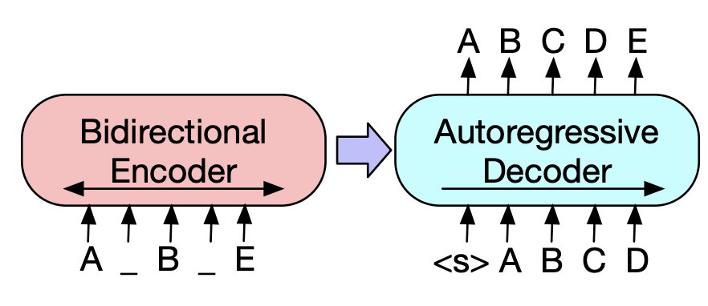
Figure 2.1. BART’s bidirectional encoder and autoregressive decoder framework, supporting effective sequence reconstruction in multilingual contexts. (Adapted from Lewis et al., 2020)
The encoder processes both left and right context (e.g., incomplete input like “A _ B _ E”), while the decoder autoregressively reconstructs the target sequence (e.g., “ABCDE”), helping recover coherent structure even when linguistic shifts disrupt continuity—common in Taglish.
Complementing BART’s generative capacity is XLM-RoBERTa (XLM-R), a transformer model trained on 100 languages using Masked Language Modeling (MLM) and Translation Language Modeling (TLM) objectives. These training schemes allow it to learn both within-language dependencies and cross-lingual alignments, enabling more flexible interpretation of multilingual inputs (Conneau et al., 2020).
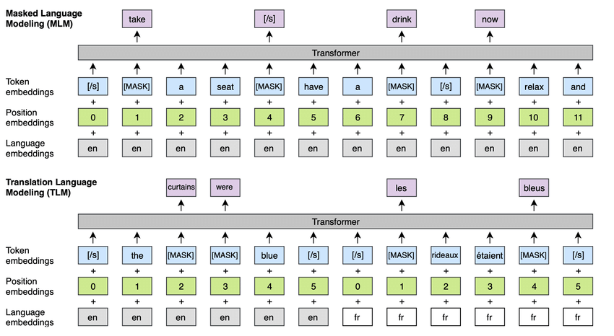
Figure 2.2. XLM-R’s dual training objectives (MLM and TLM) enable nuanced processing of both intra-language and cross-language contexts, which is critical for code-switching detection. (Adapted from Conneau et al., 2020)
In MLM, words are randomly masked, and the model must predict them based on surrounding context. In TLM, bilingual sentence pairs are presented with aligned tokens masked—teaching the model to make predictions that span across languages. These training strategies are particularly useful for capturing the fluid alternation found in Taglish, especially when syntactic coherence must be preserved across linguistic boundaries.
Although transformer models mark a significant advancement, they still struggle with low-resource and domain-specific code-switching scenarios. Even Large Language Models (LLMs) such as GPT-4 and BLOOM, while capable of zero-shot learning, show poor performance in word-level switch prediction unless explicitly fine-tuned (Zhang et al., 2023). Similarly, Winata et al. (2022) observed that multilingual LMs like XLM-R often fail to detect fine-grained alternation without targeted pretraining.
As a result, recent work has explored hybrid architectures that fuse the strengths of multiple models. Studies indicate that combining XLM-R’s robust multilingual representations with BART’s sequence generation improves performance in token classification and sentence reconstruction across mixed-language datasets. These fusion models are particularly well-suited for code-switching tasks in low-resource, linguistically fluid languages—aligning directly with the objectives of this research.

2.4 Progression of Taglish Code-Switching Detection
The development of Natural Language Processing (NLP) systems for Tagalog-English code-switching—commonly known as Taglish—has undergone significant progress over the years. Researchers have shifted from basic rule-based approaches to transformer-based techniques capable of modeling complex linguistic behaviors. This section outlines key studies that have shaped the progression of Taglish detection and highlights the challenges that remain unresolved.
Early approaches relied heavily on statistical methods and pattern-matching techniques, which were limited by their dependence on handcrafted rules and lexical frequency. For example, Bacatan et al. (2014) employed unigram and bigram models to identify code-switching points and reported high accuracy rates (81–95%) on small datasets. However, the models failed to scale well due to their reliance on word frequency counts and inability to handle intra-word switching, a phenomenon where the switch occurs within a single word or morpheme.
Expanding on these early foundations, Oco & Roxas (2012) integrated part-of-speech (POS) tagging and stopword filtering into their pattern-matching approach, achieving an accuracy of 94.51% on short, structured text. Despite these gains, their system remained fragile when applied to informal or user-generated content like social media posts, limiting its practical applicability.
A major breakthrough occurred with the creation of the TweetTaglish dataset by Herrera et al. (2022), which comprises over 20,000 examples of Tagalog-English code-switching collected from Twitter. This dataset addressed the issue of data scarcity in Taglish and provided a more representative source of natural code-switching. Using this corpus, the authors built benchmark models for detection and classification. However, the dataset’s reliance on social media introduced domain-specific biases that made generalization to formal or spoken language contexts more difficult.
In a different application area, Curada et al. (2020) developed a hybrid sentiment analysis model for evaluating professor feedback written in Taglish. Their system combined lexicon-based tagging with Naive Bayes and Support Vector Machine (SVM) classifiers, achieving a modest accuracy of 57%. The study revealed significant difficulties in analyzing more complex Taglish text, especially where sentiment cues were embedded in alternating languages.
Recent work by Cosme & De Leon (2023) used transformer-based models—specifically XLM-RoBERTa—to conduct sentiment analysis on code-switched product reviews. Their model, fine-tuned on Taglish data, achieved an accuracy of 84%, highlighting the potential of transformers in handling multilingual tasks. The study also emphasized the shortcomings of traditional lexicon-based approaches when applied to code-switched text.
These studies, summarized in Table 1, reflect a growing sophistication in the detection of Taglish, moving from frequency-driven and rule-based systems to deep learning and transformer architectures. However, challenges remain in achieving domain generalization, handling intra-word and intrasentential switches, and ensuring robustness in low-resource settings.
Table 2.1: Progression of Taglish Code-Switching Detection
Study | Year | Approach | Findings | Challenges
Bacatan et al. (2014) | 2014 | Word bigrams and unigrams | Achieved 81%-95% accuracy in detecting Tagalog-English code-switching points. | Limited by reliance on word frequency counts and applicability to larger, real-world datasets.
Oco & Roxas (2012) | 2012 | Pattern-matching refinements to dictionary-based approach | Achieved 94.51% accuracy using POS tagging and common word exclusion. | Struggled with intra-word code-switching and the limited size of the test corpus (100 sentences).
Herrera et al. (2022) | 2022 | Introduced TweetTaglish dataset | Developed a dataset of over 20,000 instances of Tagalog-English code-switching, establishing new benchmarks for studying code-switching. | Limited focus on social media data; results need further validation in other contexts, such as formal writing or long-form conversations.
Curada et al. (2020) | 2020 | Lexicon-based + hybrid machine learning | Developed a code-switching detection module for Taglish professor evaluations using hybrid models, achieving 57% accuracy for Taglish. | Struggled with lower accuracy in processing code-switched text, particularly in more complex domains, highlighting the limitations of combining lexicon-based methods with traditional machine learning models.
Cosme & De Leon (2023) | 2023 | Sentiment analysis using transformers | Achieved 84% accuracy using XLM-RoBERTa for sentiment analysis of code-switched Filipino-English reviews. | Transformer models showed strong performance, but lexicon-based approaches still underperformed in handling code-switching tasks.
Despite this progress, the field continues to face persistent issues related to domain adaptation, data scarcity, and the contextual fluidity of Taglish. Models trained on informal data may not transfer well to formal writing or spoken transcripts, and most systems still struggle to process intra-sentential and intra-word switches with high precision.
This study addresses these challenges by introducing a hybrid model that fuses XLM-RoBERTa’s cross-lingual contextual representation with BART’s sequence reconstruction capabilities. By fine-tuning this architecture on a custom Taglish dataset, the research aims to improve generalizability, capture subtle switching behavior, and contribute to a more robust pipeline for code-switching detection in low-resource multilingual environments.

CHAPTER 3

METHODOLOGY
This study adopts a structured approach to Taglish code-switching detection, covering the full pipeline from data collection and annotation to model training and evaluation. The methodology is designed to ensure that the developed models are both robust and applicable to real-world Taglish scenarios across various domains. As illustrated in Figure 3.1, the framework begins with sourcing and annotating domain-specific Taglish text, followed by a multi-model training phase and domain-aware evaluation. Ultimately, the models are deployed in a prototype to demonstrate practical utility in code-switched token classification.
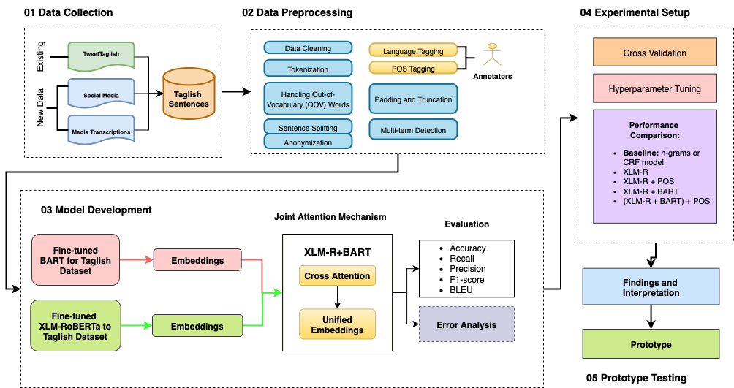
Figure 3.1 Framework for Taglish Code-Switching Detection and Analysis

3.1 Data Collection and Corpus Composition
To ensure linguistic diversity and domain coverage, a curated corpus of 5,201 Taglish sentences (comprising 54,956 tokens) was constructed from three main sources:
- Social media: Informal content from the TweetTaglish dataset, characterized by frequent switching, slang, abbreviations, and emojis.
- Spoken Transcripts: Semi-formal to formal Taglish utterances derived from publicly available YouTube podcast captions.
- Conversational Exchanges: Simulated one-on-one dialogues mimicking chat-based communication.
These sources were selected to provide syntactic and contextual variation representative of code-switching in real-world Filipino-English usage.

3.1.1 Training Set Composition
The training data for this study consists of 5,201 sentences totaling 54,956 annotated tokens. These were sourced from a variety of Taglish communication domains to capture different code-switching behaviors. The final training corpus represents a balanced mix of informal, formal, and conversational language contexts:
- TweetTaglish Dataset (Herrera et al., 2022): A large corpus of Tagalog-English tweets reflecting informal and highly variable social media usage. A substantial portion of the 20,000 available sentences was sampled for model training. This domain provided rich examples of lexical mixing, emotive punctuation, and abbreviated expressions typical of social platforms like Twitter.
- YouTube Podcast Transcripts: Formal and semi-formal utterances were extracted and transcribed from three publicly available Taglish podcasts using DownSub.com. These included:
  - POV: When You Realize You and Your Friend Are No Longer COMPATIBLE
  - POV: When Filipino Traits Become Too TOXIC
  - Should There Be Rules to a Situationship?
These sources captured sentence-level switching patterns common in structured spoken discourse.
- LazadaQA Conversational Dataset (Rivera et al., 2019): A portion of the LazadaQA-Taglish-7k dataset was incorporated as representative of conversational Taglish. Originally annotated for dialog acts, this corpus features short-form question-and-answer exchanges from the e-commerce platform Lazada Philippines. Selected sentences were re-annotated at the token level for language identification and POS tagging to match the requirements of this study. Only a portion of this dataset was used for training; the rest was held out for testing.
All three sources were combined into a single training corpus to improve the generalizability of the models and ensure exposure to diverse syntactic structures and switching scenarios.
3.1.2 Test Set (Domain-Based Evaluation)
To evaluate the performance of the model across different language domains, a domain-sensitive test set was curated. It consists of 3,000 annotated sentences, with 1,000 examples each from social media, spoken, and conversational domains:
Table 3.1 Domain-Specific Evaluation Set
Domain | Source | Example Characteristics
Social media | TweetTaglish Dataset (Herrera et al., 2022) | Informal, user-generated posts with high variability in syntax and spelling
Spoken | Captions from 3 YouTube Taglish podcast episodes | Structured discourse with fluent sentence-level switching
Conversational | LazadaQA-Taglish-7k (Rivera et al., 2019) – Subset annotated in-house for this study | Short, direct Q&A-style messages, less noise and clearer code-switching boundaries

All test sentences underwent the same annotation protocol applied to the training set, ensuring consistency in token-level language and POS tagging across domains.

3.1.3 Annotation Protocol
Each word token in the dataset was annotated with two types of linguistic information:
- Language Tagging: Every token was labeled as TAG (Tagalog), ENG (English), or OTH (others such as emojis, symbols, or named entities). This classification enables detection of intra-sentential switching and identification of noise or boundary tokens.
- Part-of-Speech (POS) Tagging: POS tags were assigned based on a simplified version of the Universal POS Tagset, helping capture syntactic roles within mixed-language sequences.
The annotation was performed using the Brat Rapid Annotation Tool. A team of three bilingual annotators, all fluent in both Tagalog and English, completed the annotation. To ensure quality and consistency, inter-annotator agreement was measured using Cohen’s Kappa, resulting in a substantial agreement score of 0.83 (Artstein & Poesio, 2008). Annotation discrepancies were resolved through consensus review sessions, assisted by a supervising linguist.
Table 3.2 Dataset Composition and Annotation Summary
Source | Sentence Count | Domain | Annotation Type | Annotators | Agreement (κ)
TweetTaglish | Subset of 20,000 | Social Media | Language, POS | 3 | 0.83
YouTube Podcasts | Transcribed | Spoken | Language, POS | 3 | 0.83
LazadaQA (subset) | Re-annotated | Conversational | Language, POS | 3 | 0.83
Total | 5,201 | All Domains | Token-Level Annotation

3.1.4 Multi-Term Expressions
Beyond token-level annotation, the dataset also accounted for multi-term expressions collocations and borrowed phrases that function as single semantic units in Taglish discourse. These occur in two forms:
- English Collocations Borrowed Wholesale – phrases such as “credit card limit,” “out of stock,” “terms and conditions” are widely adopted in Filipino communication and are treated as fixed borrowed units.
- Taglish Hybrid Collocations – mixed constructions where a Tagalog verb or particle combines with an English collocation, e.g., “mag-submit ng requirements,” “kuha ng screenshot,” “nag-send ng message.”
These multi-term expressions were flagged during annotation to preserve their coherence and avoid fragmented token-level treatment. Validation followed the same protocol as token annotation: annotators highlighted recurring collocations and resolved disagreements through consensus discussions with a supervising linguist. By explicitly considering these expressions, the dataset reflects both direct English borrowings and Taglish-specific hybrids, ensuring more accurate representation of real-world Filipino-English usage.
Table 3.3 Examples of Multi-Term Expressions in Taglish
Expression Type | Example Expression | Notes on Usage
English Collocation (Borrowed) | credit card limit | Used directly in financial and e-commerce chats
English Collocation (Borrowed) | out of stock | Common retail/marketplace phrase
English Collocation (Borrowed) | terms and conditions | Formal borrowing in online platforms
Taglish Hybrid Collocation | mag-submit ng requirements | Tagalog verb + English noun phrase
Taglish Hybrid Collocation | kuha ng screenshot | Tagalog root verb + English borrowed noun
Taglish Hybrid Collocation | nag-send ng message | Tagalog affixation + English base verb

3.2 Preprocessing Steps
After annotation, several preprocessing steps were applied to standardize and prepare the dataset for training and evaluation:
- Text Cleaning: Non-linguistic elements such as URLs, excessive punctuation, emojis, and HTML entities were removed to minimize noise, especially in social media and conversational inputs.
- Anonymization of Sensitive Data: Usernames, email addresses, phone numbers, and other identifiable entities were anonymized using rule-based masking. For example, patterns such as @username, 0917-XXXXXXX, or email@example.com were replaced with placeholders like @user, [PHONE], and [EMAIL] respectively. This step ensures data privacy and ethical compliance in using publicly available conversational and social media text.
- Multi-term Detection and Processing: To address intra-word code-switching, tokens are explicitly classified as English (ENG), Filipino (TAG), or Mixed/Taglish (MIX). Mixed tokens—such as magda-drive or nagte-text—contain morphemes from both languages and are identified using a hybrid approach: language identification scores from fastText models trained on monolingual corpora, combined with morphological rules adapted from code-switching studies (Çetinoğlu et al., 2016; Solorio & Liu, 2008). This ensures that blended tokens are preserved as distinct linguistic units, improving feature representation and model learning in multilingual contexts (Bautista et al., 2022; Rijhwani et al., 2020).
- Lowercase Standardization: All text was converted to lowercase to reduce lexical sparsity due to capitalization differences.
- Tokenization: Sentences were tokenized at the word level. Given the multilingual and non-standard nature of the data, special handling was applied to preserve the integrity of multi-token expressions and code-switched phrases.
- Handling Out-of-Vocabulary (OOV) Tokens: Subword tokenization (e.g., SentencePiece or Byte-Pair Encoding) was used during model input preparation to handle rare or misspelled terms commonly found in Taglish.
- POS Tag Simplification: To ensure compatibility with model training, POS tags were normalized using a reduced Universal POS Tagset schema.
- Annotation Validation: Automated scripts validated the alignment between tokens, language tags, and POS labels. Any mismatches or missing values were flagged and resolved through manual correction by the annotation team.

3.3 Data Format and Storage
The final dataset was formatted in multiple structures, including CSV, CoNLL, and JSON, to ensure compatibility with various Natural Language Processing (NLP) tools and frameworks. Each sentence in the dataset is uniquely identified, with detailed annotations facilitating a wide range of linguistic analyses.

3.3.1 Example of Annotated Sentence
Table 3.4 presents how a sentence from the dataset is annotated. The annotation includes language tags for each word, POS tags, and a sentiment label for the entire sentence.
Table 3.4. Example of an annotated sentence from the dataset.
Token | Language Tag | POS Tag
I | ENG | PRON
love | ENG | VERB
paano | TAG | ADV
mo | TAG | PRON
ginawa | TAG | VERB
ito | TAG | PRON
because | ENG | CONJ
it | ENG | PRON
looks | ENG | VERB
so | ENG | ADV
amazing | ENG | ADJ
With this systematic approach to data collection and preprocessing, this annotated dataset is designed to support a wide range of linguistic analyses in code-switching research. Also, ethical guidelines were strictly followed during the data collection and annotation process, including the anonymization of personal data and obtaining necessary permissions for scraping and transcription from online sources.

3.4 Model Development
To evaluate the effectiveness of transformer-based models in detecting code-switching within Taglish text, this study developed and compared three architectures: (1) a baseline n-gram model, (2) a transformer-based XLM-RoBERTa token classifier, and (3) a hybrid model combining XLM-R and BART. This section outlines the mathematical and architectural foundations of each, including their roles, components, and training procedures.

3.4.1 Baseline Model: Character N-Gram with Logistic Regression
The baseline model serves as a lightweight, interpretable benchmark for comparison. It operates on the assumption that lexical cues alone—specifically, subword patterns—may be enough to distinguish between languages at the token level.
- Feature Representation: Character-level n-gram features (unigrams to trigrams) were extracted using a CountVectorizer, capturing subword patterns such as "ka", "ing", and "tao" that are indicative of Tagalog or English morphology.
- Classifier: A logistic regression model was trained using these features to assign one of three labels: TAG (Tagalog), ENG (English), or OTH (Other).
- Limitations: This model lacks context and treats each token in isolation, making it prone to errors in ambiguous or cross-linguistic tokens (e.g., like, na, actually). Nonetheless, it establishes a lower-bound benchmark for code-switching detection accuracy.

3.4.2 Transformer Architecture Overview
Both XLM-RoBERTa and BART utilize the transformer architecture, which is powered by the self-attention mechanism. This mechanism allows the model to weigh the importance of each token in the sentence relative to others, capturing complex dependencies that occur in code-switched text. Transformers, with their ability to process contextual dependencies over long sequences, have proven highly effective in complex NLP tasks, especially in multilingual and mixed-language contexts. This makes them ideal for code-switching detection, where maintaining context across languages is essential (Vaswani et al., 2017). The attention mechanism is defined by the following formula:
$$Attention (Q,K,V) = softmax\left(\frac{QK^{T}}{\sqrt{dq}}\right)v$$
Where:
- Q represents the query matrix,
- K is the key matrix,
- V is the value matrix,
- and dk​ is the dimensionality of the key vectors.
This self-attention mechanism is central to both XLM-RoBERTa and BART, allowing them to capture long-range dependencies across languages in a code-switched sentence.

3.4.3 XLM-RoBERTa for Multilingual Contextual Understanding
XLM-RoBERTa (XLM-R) is a multilingual transformer-based model that extends RoBERTa’s architecture to handle cross-lingual tasks. XLM-RoBERTa is trained using the masked language modeling (MLM) objective, where a percentage of the tokens in the input sequence are masked, and the model learns to predict the masked tokens based on their context. This approach enables XLM-R to learn language-agnostic embeddings that facilitate code-switching detection. The training objective for MLM is expressed as:
$$LMLM = -\sum_{i=1}^{N}{}logP(x_{i}|\hat{x} i)$$
Where:
- $x_{i}$ is the masked token, and
- $\hat{x} i$​ represents the surrounding context.
XLM-RoBERTa’s ability to predict missing tokens in multiple languages allows it to capture cross-lingual embeddings that are crucial for understanding the code-switching patterns in Taglish. This makes XLM-RoBERTa especially effective for low-resource languages like Filipino (Conneau et al., 2020).

3.4.4 BART for Sequence Generation and Text Reconstruction
BART (Bidirectional and Auto-Regressive Transformers) is a language model designed for tasks like text generation and sequence reconstruction. BART is trained as a denoising autoencoder, where it learns to generate the original text from corrupted or incomplete sequences. BART’s autoregressive decoding allows it to manage shifts in syntax due to language alternation within sentences, making it particularly useful for code-switched text (Lewis et al., 2020). Its training objective is expressed as:
$$LBART = -\sum_{i=1}^{N}{}logP(x_{i}|y)$$
Where:
- $y$ represents the noisy or corrupted input sequence, and
- $x_{i}$ represents the correct token to be generated.
In code-switched sentences, BART’s sequence reconstruction capability ensures fluent and coherent transitions between Tagalog and English, as seen in sentences like "Punta tayo sa park later, the weather seems nice."

3.4.5 Fine-Tuning Strategy
Before the fusion of the two models, fine-tuning was applied to both XLM-RoBERTa and BART using a custom dataset of Taglish sentences. Fine-tuning is crucial for adapting each model to the specific characteristics of Taglish, which combines both Filipino and English in a single sentence.
- XLM-RoBERTa Fine-Tuning:
  - XLM-R is fine-tuned to better capture cross-lingual transitions between Filipino and English, ensuring it can contextualize both languages seamlessly in a code-switched setting.
- BART Fine-Tuning:
  - BART is fine-tuned to ensure sequence generation and reconstruction in Taglish, enabling it to generate fluent output even when the sentence structure changes due to language switching.
Fine-tuning of XLM-RoBERTa and BART individually optimizes each model for its role in the hybrid architecture. XLM-RoBERTa is calibrated to prioritize cross-lingual contextual understanding, while BART is enhanced for generating fluent transitions in code-switched sentences. Fine-tuning occurs before the fusion, optimizing each model individually for cross-lingual understanding and sequence generation.

3.5 Hybrid Approach and Fusion Mechanism
Once the models are fine-tuned, their outputs are combined in the fusion mechanism, which integrates XLM-RoBERTa’s embeddings with BART’s sequence generation. This fusion captures both contextual understanding and syntactic fluency in the final output.
Hybrid models have shown significant promise in handling cross-lingual and code-switching tasks by combining the strengths of multiple architectures. For instance, Winata et al. (2021) demonstrated a notable improvement in cross-lingual speech recognition using a similar hybrid approach. Zhang et al. (2023) further emphasized that while multilingual transformers perform well in zero-shot learning tasks, they benefit considerably from hybrid architectures when handling code-switched text. The fusion process involves concatenating the embeddings generated by both models and applying a joint attention mechanism. The mathematical formulation of the fusion mechanism is as follows:
$$Hfusion = Attention (H XLM-R ⊕H BART)$$
Where:
- $Hfusion$​ represents the final hybrid embeddings,
- $HXLM-R$​ are the embeddings from XLM-RoBERTa,
- $HBART$ are the embeddings from BART,
- and ⊕ denotes the concatenation of the two embeddings.
This mechanism allows the hybrid model to leverage both XLM-RoBERTa’s cross-lingual capabilities and BART’s generative fluency, producing coherent and contextually accurate code-switching predictions. While concatenation offers a straightforward fusion approach, alternative methods such as attention-based fusion allow for more nuanced integration of both models, giving higher weight to contextually important embeddings.

3.5.1 Model Fusion
The architecture of the hybrid model is designed to address the specific challenges of Taglish code-switching by leveraging the complementary strengths of XLM-RoBERTa and BART. XLM-RoBERTa, trained on over 100 languages using masked language modeling, excels at generating token-level multilingual embeddings that preserve context and capture language boundaries—key in detecting subtle code-switches. However, its encoder-only design limits its capacity to reconstruct sentence-level coherence, particularly in cases of informal or syntactically irregular Taglish utterances.
In contrast, BART offers a sequence-to-sequence framework that reconstructs input text using both an encoder and an autoregressive decoder. This structure allows it to model sentence fluency and restore disrupted patterns caused by mid-sentence language switches. By integrating XLM-R’s contextual awareness with BART’s fluency-oriented decoding, the fusion layer enables the model to capture both where language switches occur and how they affect sentence structure and meaning. This joint attention mechanism helps the model weigh contributions from each backbone, resulting in more accurate predictions, especially in cases where standard grammatical cues are absent.
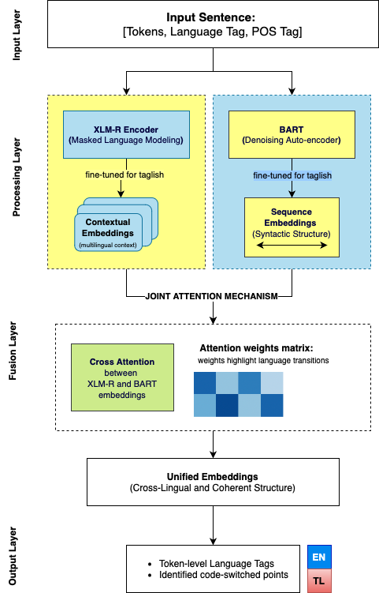
Figure 3.2 Fusion layer combining XLM-RoBERTa's multilingual embeddings with BART's sequence embeddings using a joint attention mechanism
In this process, an input Taglish sentence is first processed independently by XLM-RoBERTa and BART, producing two complementary types of embeddings. XLM-RoBERTa captures multilingual contextual representations, allowing the model to understand token-level dependencies across Tagalog and English. However, its encoder-only structure limits sequence-level coherence, especially in noisy or informal language. On the other hand, BART contributes sequence-level understanding by reconstructing the intended flow of language using an encoder-decoder setup, which is particularly helpful for handling incomplete or fragmented input.
These outputs are then fused using a joint attention mechanism, allowing the model to simultaneously attend to multilingual context and generative fluency. This integration addresses two common challenges in Taglish code-switching: capturing fine-grained language alternation and preserving sentence coherence despite informal or non-standard syntax. By combining XLM-RoBERTa’s strength in cross-lingual alignment with BART’s ability to reconstruct well-formed sentences, the hybrid architecture is better equipped to detect and interpret code-switching boundaries in real-world Taglish inputs.

3.6 Experimental Setup
The experimental setup evaluates multiple model configurations for Taglish code-switching detection, focusing on token-level classification accuracy, cross-domain generalization, and model efficiency. As illustrated in Figure 3.3, the workflow begins with the annotated dataset, which is split into training, validation, and domain-specific test sets. These subsets are used to train and tune multiple baseline and transformer-based models. The figure also highlights the evaluation across three domains—social media, spoken transcripts, and conversational text—measured using accuracy, precision, recall, F1-score, and computational complexity. This section further details the dataset split strategy, domain-specific evaluation, hyperparameter tuning methodology, baseline and transformer model comparisons, and a brief complexity analysis.
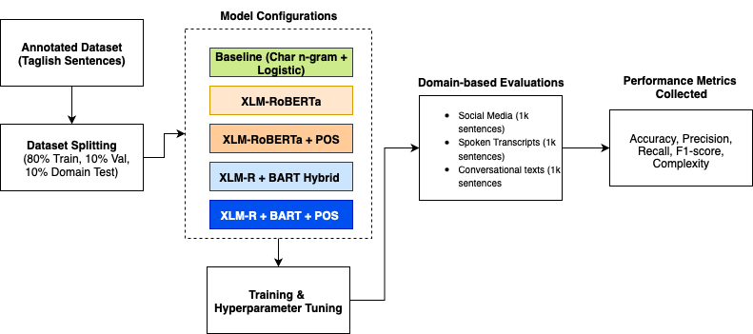
Figure 3.3 Experimental setup workflow for Taglish code-switching detection.

3.6.1 Dataset Splitting and Domain-Based Evaluation
To test the models' generalizability across usage contexts, evaluation was conducted on three distinct domains: social media, spoken transcripts, and conversational data. A total of 3,000 manually annotated sentences were reserved as a fixed test set, with 1,000 samples per domain. These test sets were excluded from all training and validation procedures.
The remaining annotated data was used to train and validate all model configurations:
- Training Set: 80% of the annotated corpus
- Validation Set: 10% (used during training for tuning and early stopping)
- Domain-Specific Test Set: 10% (fixed: 1,000 sentences per domain)
Each model was evaluated independently on these test sets to assess cross-domain robustness and switching behavior variation.

3.6.2 Model Variants and POS Integration
The experimental pipeline included five core model configurations:
- Baseline Model: Character n-gram features + Logistic Regression
- XLM-RoBERTa: Contextual encoder without POS
- XLM-RoBERTa + POS: Token classifier with concatenated POS embeddings
- XLM-R + BART Hybrid: Fused embeddings from both encoders
- XLM-R + BART + POS: Hybrid model enhanced with POS tag embeddings
POS tagging was integrated into the XLM-R and hybrid models using a fixed-size embedding layer. The POS feature allowed the model to learn syntactic cues and was ablated in some configurations to evaluate its contribution.
Each configuration was trained and evaluated separately, and performance was compared based on token-level precision, recall, and F1-score.

3.6.2 Model Variants and POS Integration
The experimental pipeline included five core model configurations:
- Baseline Model: Character n-gram features + Logistic Regression
- XLM-RoBERTa: Contextual encoder without POS
- XLM-RoBERTa + POS: Token classifier with concatenated POS embeddings
- XLM-R + BART Hybrid: Fused embeddings from both encoders
- XLM-R + BART + POS: Hybrid model enhanced with POS tag embeddings
POS tagging was integrated into the XLM-R and hybrid models using a fixed-size embedding layer. The POS feature allowed the model to learn syntactic cues and was ablated in some configurations to evaluate its contribution. Each configuration was trained and evaluated separately, and performance was compared based on token-level precision, recall, and F1-score.

3.6.4 Baseline Comparison
To contextualize the performance of transformer-based models, a traditional baseline was implemented:
- Character N-Gram + Logistic Regression: Tokens were classified based on their subword structure, ignoring context. This approach established a lower-bound performance estimate.
- No POS or sentence-level context was used in the baseline.
In addition, ablation studies compared:
- XLM-R vs. XLM-R + POS
- XLM-R + BART vs. XLM-R + BART + POS
These comparisons isolated the individual contributions of contextual encoding, POS features, and dual-encoder fusion.

3.6.5 Domain-Specific Evaluation Protocol
Each model was evaluated independently per domain, using the same 1,000-sentence test set for:
- Social Media: Informal, user-generated TweetTaglish content
- Spoken Transcripts: Structured captions from podcasts
- Conversational Text: Short-turn dialogues from e-commerce Q&A
Performance metrics included token-level accuracy, precision, recall, and macro/weighted F1-score. Results were reported per class (TAG, ENG, OTH) and aggregated using macro and weighted averages.

3.6.6 Computational Complexity Considerations
While the main focus was on classification performance and generalization, rough estimates of time and memory complexity were recorded.
- Time Complexity: Self-attention computation in transformer encoders (XLM-R and BART) has a theoretical time complexity of $O(n^{2}* d)$, where n is the input sequence length and d is the hidden dimension. This quadratic complexity arises from computing the pairwise dot products for each token in the sequence (Vaswani et al., 2017). Time complexity will be measured during training and inference to provide an actual estimate.
- Space Complexity: Approximate space usage is $O(n*d+n^{2})$, driven by embedding storage and attention matrices.
GPU memory usage and training time per epoch were monitored empirically during model runs to understand feasibility in downstream deployment scenarios.

3.6.7 Hardware and Software Requirements
The experiments were conducted using both local and cloud-based computational resources.
Hardware Configuration
- Local Machine: MacBook Pro (Apple M2, 2022)
- Processor: 8-core CPU with integrated 10-core GPU
- Memory: 8 GB unified RAM
- Storage: 512 GB SSD
- Operating System: macOS Ventura 14.x
- Supplementary Resource: Google Colab Pro with NVIDIA T4 GPU was occasionally used to accelerate training runs.
Software Environment
- Programming Language: Python 3.10
- Deep Learning Framework: PyTorch (v2.x)
- Pretrained Models: Hugging Face Transformers (XLM-RoBERTa, BART)
- Supporting Libraries: pandas, numpy, scikit-learn, matplotlib, seaborn, tqdm
Dependencies and Model Requirements
- XLM-RoBERTa (XLM-R) – for multilingual contextual embeddings
- BART – for sequence modeling in the hybrid architecture
- Tokenizers – SentencePiece-based tokenization for preprocessing
- Evaluation Tools – scikit-learn metrics for precision, recall, F1-score, accuracy, MCC, log-loss, and ROC-AUC
- Hyperparameter Tuning – included adjustments for learning rate, batch size, dropout, maximum sequence length, and number of epochs to optimize model performance
This configuration ensured sufficient computational efficiency to train and evaluate baseline, transformer-based, and hybrid architectures for Taglish code-switching detection.

3.7 Evaluation Metrics
To comprehensively evaluate the performance of the hybrid model in detecting and processing Taglish code-switching, a combination of standard Natural Language Processing (NLP) metrics, code-switching-specific metrics, and computational complexity measurements will be employed.

3.7.1 Standard NLP Metrics
- Accuracy: Accuracy measures the proportion of correct predictions (both positive and negative) among the total predictions. For the code-switching detection task, it evaluates the model's overall ability to identify the correct language at each token.
$$Accuracy = \frac{TP + TN}{TP + TN + FP + FN}$$Where:
  - TP = True Positives
  - TN = True Negatives
  - FP = False Positives
  - FN = False Negatives
- Precision, Recall, and F1-Score: These metrics will provide a more nuanced evaluation than accuracy alone, especially in cases of class imbalance, where code-switching instances may be fewer compared to monolingual segments.
  - Precision measures the proportion of correctly identified code-switching points among all predicted switch points:
$$Precision = \frac{TP}{TP + FP}$$
  - Recall evaluates the proportion of actual code-switching points correctly identified by the model:
$$Recall = \frac{TP}{TP + FN}$$
  - F1-Score offers a harmonic mean of precision and recall, providing a single measure to assess the balance between them:
$$F1-score = 2x \frac{Precision×Recall}{Precision + Recall}$$
- BLEU Score: The BLEU (Bilingual Evaluation Understudy) score will be used to measure the quality of sequence generation by BART, evaluating the n-gram overlap between generated sentences and reference sentences:
$$BLEU = BP × exp\left(\sum_{n-1}^{N}{}w_{n}log{ p}_{n}\right)$$Where:
  - $BP$ is the brevity penalty to penalize short generated sentences.
  - $w_{n}$represents the weights for different n-grams.
  - ​$p_{n}$ denotes the precision for n-gram matches.

3.7.2 Code-Switching Specific Metrics
- Code-Switching Point Detection: Evaluates the ability of the model to detect language alterations. Precision, recall, and F1-Score will be calculated specifically for detecting transition points, which are crucial for understanding mixed-language text.
- Language Identification Accuracy: This metric measures the model’s accuracy in tagging each token with the correct language (Tagalog or English). High performance in language identification is essential for the model's overall effectiveness in processing code-switched text.

3.7.3 Error Analysis
- Error Types: Analyzing false positives and false negatives helps identify common patterns in model errors. This will guide further improvements to the model's architecture or training strategies.
- Contextual Analysis: Errors will be examined across different text domains, such as social media versus formal writing, to understand the model's limitations in diverse settings.

3.7.4 Computational Complexity
- Time Complexity: The model's time complexity will be monitored during training and inference to ensure scalability. Given that transformer-based models like XLM-RoBERTa and BART typically exhibit $O(n^{2}* d)$ time complexity (where nn is the sequence length and d is the dimensionality), the experimental results will be compared against these theoretical values.
- Space Complexity: The space complexity will be evaluated by monitoring memory usage, given the model's dependence on storing multiple layers of weights and attention matrices. Typically, the space complexity for transformers is around $O(n*d+n^{2})$,, and this will be assessed to confirm the model’s suitability for deployment in low-resource environments.

3.7.5 Validation and Testing
All models were validated using 10-fold stratified cross-validation, ensuring balanced representation of Taglish switching behaviors in each fold. A fixed 3,000-sentence test set (1,000 per domain) was held out for final evaluation, unseen during training and tuning.
This rigorous evaluation framework supports a well-rounded understanding of the model's strengths and limitations across linguistic, contextual, and computational dimensions.

3.8 Ethical Considerations
This study complies with ethical standards in data handling, annotation, and responsible AI development. All textual data— including the TweetTaglish dataset (Herrera et al., 2022), transcriptions from publicly available YouTube podcasts, and Taglish e-commerce conversations from Rivera et al. (2019)—were sourced from public or research-authorized domains under fair academic use.
To protect individual privacy, potentially identifiable information such as usernames, email addresses, and named entities was manually and programmatically anonymized during preprocessing. No private, login-restricted, or confidential materials were collected or processed.
The dataset was annotated by three trained bilingual annotators, ensuring cultural and linguistic awareness while minimizing labeling bias. The model was trained using a balanced dataset covering social media, spoken, and conversational domains to promote fairness across communication contexts.
This research adheres to the Data Privacy Act of 2012 (RA 10173), GDPR principles, and core values of inclusivity and transparency in NLP. Any future deployment of the model must undergo ethical review and continuous oversight to mitigate potential risks, such as misuse or unfair representations.

CHAPTER 4

RESULTS AND DISCUSSION

4.1 Experimental Framework
This section presents the experimental framework adopted for evaluating the performance of five model configurations designed to detect code-switching in Taglish. The models include a statistical baseline, XLM-RoBERTa, XLM-RoBERTa with part-of-speech (POS) tagging, a hybrid model combining XLM-R and BART, and the same hybrid model augmented with POS tags.
All experiments were conducted on a balanced, multi-domain annotated dataset consisting of social media posts, spoken transcripts, and conversational exchanges sourced from platforms such as Twitter, Facebook, and TikTok. The dataset consists of 54,956 tokens, each annotated with a language label—Tagalog (TAG), English (ENG), or Other (OTH)—and a corresponding part-of-speech tag. Evaluation followed the token-level metrics defined in Chapter 3: accuracy, precision, recall, F1-score, and support count for each label class. Weighted and macro averages were also computed to provide balanced insight across the class distribution.
This evaluation framework serves to empirically assess how each model configuration performs on highly variable and informal Taglish text, with results presented in the following subsections.

4.2 Model Evaluation and Comparison
Five model variants were evaluated to determine their effectiveness in detecting code-switching at the token level. All experiments were conducted on a common annotated dataset comprising 54,956 tokens. Table 4.1 summarizes the weighted performance of each model, while Figure 4.1 provides a visual comparison of F1-scores.
Table 4.1. Summary of Evaluation Metrics Across Models
Model | Accuracy | Precision (Weighted) | Recall (Weighted) | F1-Score (Weighted)
Baseline | 0.51 | 0.88 | 0.50 | 0.64
XLM-R | 0.78 | 0.79 | 0.78 | 0.78
XLM-R + POS | 0.79 | 0.80 | 0.79 | 0.79
Hybrid | 0.85 | 0.84 | 0.85 | 0.84
Hybrid + POS | 0.89 | 0.88 | 0.89 | 0.89
The Hybrid + POS model achieved the highest overall performance, with an F1-score of 0.89 and an accuracy of 0.89. The inclusion of POS tags in the hybrid architecture enabled more precise disambiguation of multi-term mixed expressions, particularly in cases where language shifts occurred within compound words or fixed expressions. The Hybrid model without POS tags also performed strongly (F1-score of 0.84) but exhibited slightly lower recall in detecting rare code-switching patterns. XLM-R and its POS-enhanced variant showed balanced yet lower performance, likely due to the absence of a joint attention mechanism. The statistical baseline attained high precision (0.88) but suffered from very low recall, making it less effective for this task.
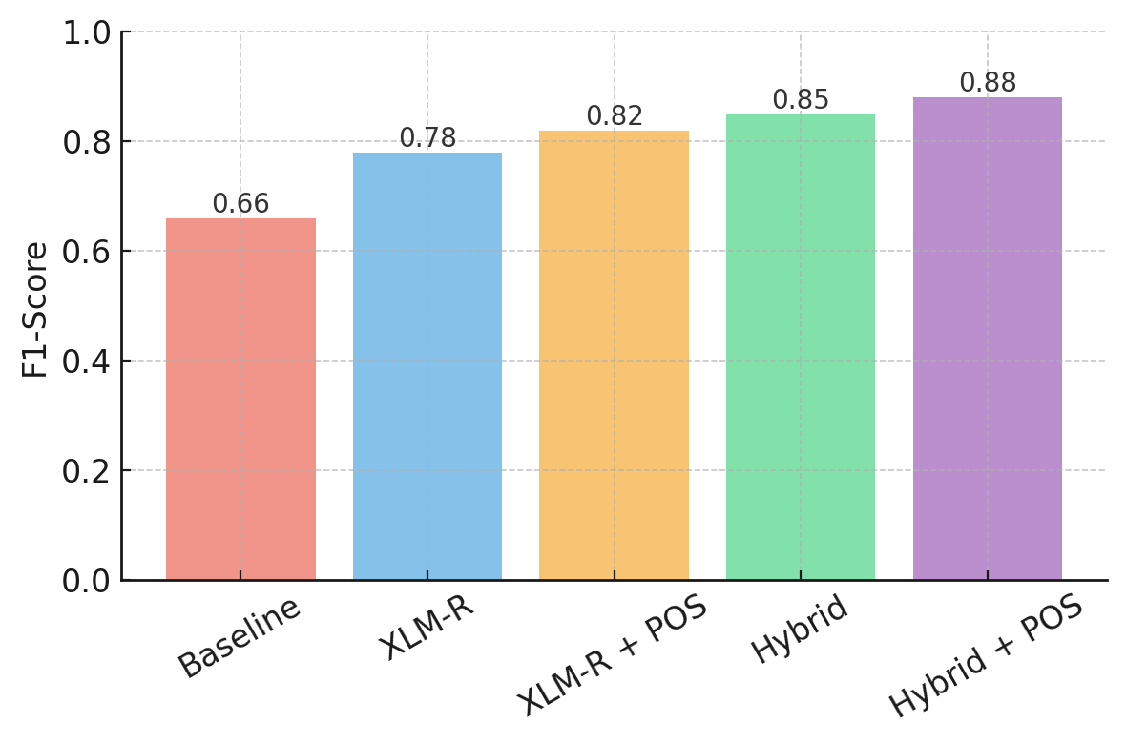

Figure 4.1. F1-Score Comparison Across Models
As shown in Figure 4.1, the hybrid model demonstrated a notable advantage over the other configurations. The addition of POS tags to the hybrid setup did not result in substantial improvement, indicating that contextual embeddings and sequence-level reconstruction already provided strong performance.

4.3 Model Evaluation and Comparison
To examine the effect of multi-term detection, the hybrid model was evaluated under two configurations: with and without the preprocessing step. As shown in Figure 4.2, incorporating multi-term detection resulted in a modest yet consistent improvement across all metrics. Accuracy increased from 0.880 to 0.895, while the F1-score rose from 0.860 to 0.873. Precision and recall each improved by approximately 1.5%.
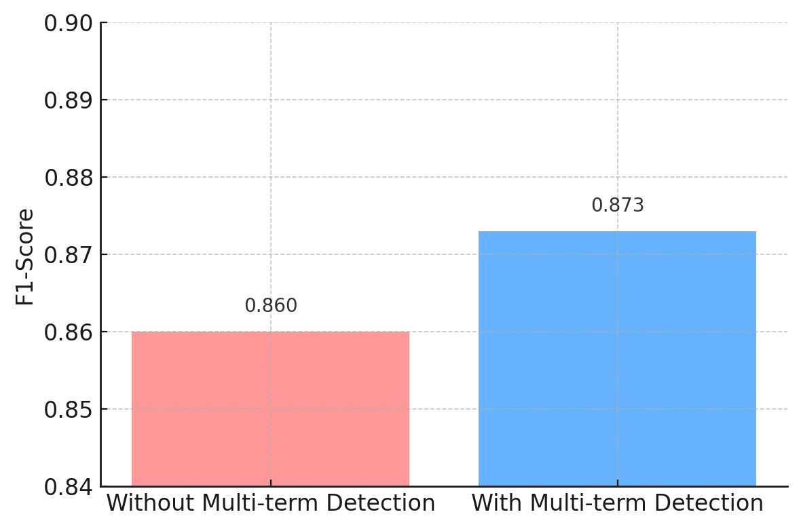
Figure 4.2. Hybrid Model Performance With and Without Multi-term Detection
Although the gain appears minimal, it is meaningful in the context of token-level code-switching detection, where performance is often constrained by the complexity of intrasentential language mixing. Multi-term detection helped the model better identify sequences spanning multiple tokens that belong to the same semantic unit but differ in language, such as “nag-overtime work” or “mag-ooffice duty.” These expressions are frequent in Taglish and can be misclassified when split into isolated tokens without considering multi-word dependencies.
The small but consistent improvements indicate that multi-term detection plays a supporting role in enhancing the hybrid model’s robustness, particularly in reducing minor classification errors for blended or compound expressions.

4.4 Per-Class Behavior and Token-Level Analysis
To gain deeper insight into model performance, we analyzed precision, recall, and F1-scores for each language label: TAG (Tagalog), ENG (English), and OTH (Other). The OTH category includes punctuation, named entities, numbers, and tokens that do not belong to either language.
Table 4.2. Per-Class Performance Across All Models
Model | Class | Precision | Recall | F1-Score | Support
Baseline | TAG | 0.87 | 0.45 | 0.59 | 25,613
 | ENG | 0.89 | 0.60 | 0.72 | 14,979
 | OTH | 0.03 | 0.82 | 0.06 | 472
XLM-R | TAG | 0.80 | 0.94 | 0.86 | 33,776
 | ENG | 0.84 | 0.66 | 0.74 | 20,320
 | OTH | 0.00 | 0.00 | 0.00 | 860
XLM-R + POS | TAG | 0.81 | 0.95 | 0.87 | 33,776
 | ENG | 0.85 | 0.67 | 0.75 | 20,320
 | OTH | 0.00 | 0.00 | 0.00 | 860
Hybrid | TAG | 0.88 | 0.96 | 0.92 | 33,776
 | ENG | 0.87 | 0.88 | 0.88 | 20,320
 | OTH | 0.00 | 0.00 | 0.00 | 860
Hybrid + POS | TAG | 0.91 | 0.96 | 0.93 | 33,776
 | ENG | 0.90 | 0.89 | 0.89 | 20,320
 | OTH | 0.01 | 0.02 | 0.01 | 860
Across all configurations, the TAG label achieved the highest recall, showing that Tagalog tokens were consistently well-recognized. The highest TAG performance was from the Hybrid + POS model, achieving an F1-score of 0.93, driven by its enhanced ability to resolve ambiguous intra-word switches.
For ENG, the baseline achieved high precision but low recall, suggesting conservative but incomplete detection. Transformer-based models improved recall substantially, with the Hybrid + POS model achieving the best balance (F1-score of 0.89), indicating more reliable English token identification in mixed contexts. The OTH label remained the most challenging category for all models, mainly due to its small representation (860 tokens) and heterogeneous content (symbols, emojis, rare named entities). Transformer-based models struggled to generalize over such irregular patterns, often defaulting to TAG or ENG predictions. While the baseline achieved higher recall for OTH, it came at the expense of very low precision, making the outputs unreliable. These results reaffirm that modern transformer architectures, particularly Hybrid + POS,l are highly effective for structured bilingual token detection (TAG and ENG) but require further augmentation to handle noisy, infrequent, or non-linguistic tokens in the OTH category

4.5 Error Analysis and Token Confusions
While the Hybrid + POS model achieved the highest overall performance, a closer examination of token-level predictions on real-world Taglish inputs reveals recurring weaknesses. These errors arise from the nuanced and often unpredictable structure of Taglish, where code-switching patterns frequently cross morphological and syntactic boundaries. Figure 4.3 presents sample outputs from the prototype interface, with each token color-coded according to its predicted label.
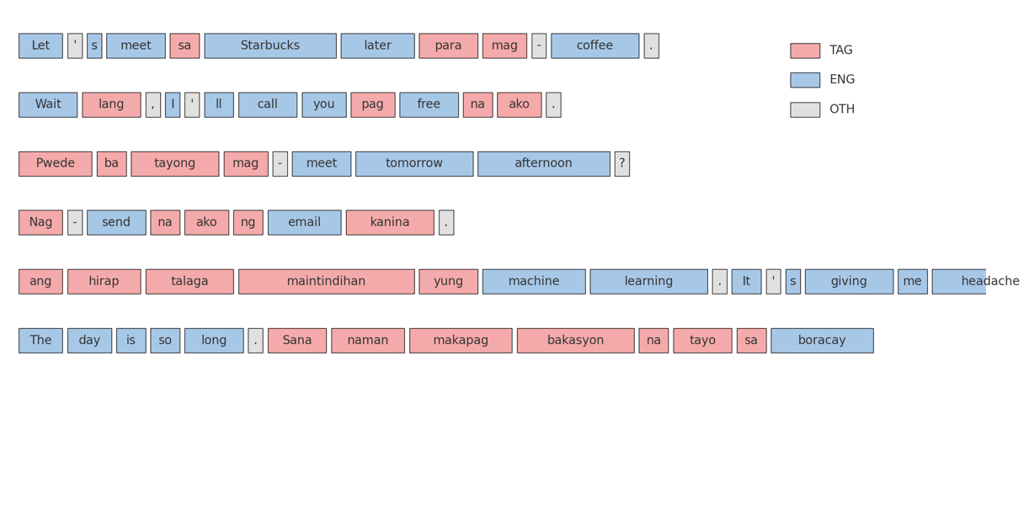
Figure 4.3. Error Analysis and Misclassifications
Observed Error Patterns and Causes
- Functional word misclassification due to adjacency effects.
Short Tagalog particles such as pag, na and ba are encoded with relatively little internal information, so the transformers rely heavily on surrounding context to classify them. In sentences like “Wait lang, I’ll call you pag free na ako,” the self-attention mechanism gives more weight to the adjacent English words (“free”, “call”), which are frequent in the pre-training corpus. Because the XLM-R and BART encoders were frozen during fine-tuning, their contextual embeddings preserve these English biases. As a result, the classifier projects the embedding of pag or na closer to the English label space. This reveals a limitation of cross-lingual encoders: without language-specific lexical features or affix indicators, the model cannot counteract contextual domination when Tagalog particles occur in an English-heavy clause.
- Inconsistent handling of affixed verb phrases.
Mixed verbs like mag-meet and nag-send illustrate a tokenisation problem. The WordPiece/BPE vocabularies of XLM-R and BART do not contain hyphenated forms, so these verbs are split into the prefix and the English root. During alignment, the model treats them as independent tokens: the prefix embedding aligns with Tagalog while the English root aligns with the English label. There is no cross-token mechanism to propagate the Tagalog prefix information to the root. In theory, joint modelling with a conditional random field (CRF) layer or affix embeddings could enforce consistent labelling across subwords, but our implementation uses independent softmax classifiers. The inconsistency therefore stems from subword segmentation and the lack of morphological features.
- Misclassification of loanwords in digital contexts.
Taglish text often includes loanwords borrowed from English technology domains (e.g., email, nag-send, mag-upload). The base multilingual encoders learned strong English representations during pre-training, so the embedding of “send” strongly activates the English classifier. Even when “send” is preceded by “nag-”, the combined embedding remains dominated by the English subword vector. This bias is exacerbated by limited representation of such hyphenated forms in our training set. Without explicit multi-term supervision or synthetic augmentation of Taglish verb phrases, the model tends to label the English root as English and the Tagalog affix as Tagalog, producing a split prediction for a single semantic unit.
- Domain-specific term confusion.
Rare, domain-specific expressions such as machine learning, data science, and interest rate appear infrequently (or not at all) in the annotated corpus. Because the model is trained to maximise token-level likelihoods over observed data, it fails to learn strong language priors for these bigrams. When such phrases occur in a Taglish sentence, their embeddings are influenced by nearby Tagalog tokens and may drift toward the Tagalog label. The domain shift highlights the importance of training on diversified corpora and of expanding the gazetteer with domain lexicons; otherwise, technical terms will be misclassified or not recognised as multi-token English expressions.
- Named entities and proper noun bias.
Proper nouns (locations, surnames, product names) are out-of-vocabulary for the model and often receive random initial embeddings. During fine-tuning, these embeddings are updated based on their context, which in a Taglish sentence is usually Tagalog. Consequently, the classifier learns a prior that unknown tokens are more likely Tagalog. In the example “The day is so long. Sana naman makapag bakasyon na tayo sa Boracay,” the model assigns Boracay to the Tagalog label because the training corpus rarely tags location names as English. This underscores the need for a dedicated “Other” or named-entity class with separate modelling, or the integration of external NER systems to correctly tag proper nouns regardless of the surrounding language.
Implications for Model Design
These technical observations point to three key areas for improvement:
- Morphologically aware tokenisation. Incorporating affix detectors or training a joint tokenizer that keeps Tagalog prefixes attached to English roots would allow the model to treat mag-meet and similar forms as single units. Alternatively, adding a CRF layer or label consistency constraint could encourage the model to assign the same language tag across sub words within a compound verb.
- Data augmentation and domain coverage. Synthetic augmentation of hyphenated loanwords and enrichment of the training corpus with domain-specific expressions (technology, finance, education) would reduce confusion on phrases like machine learning or interest rate. Likewise, expanding the gazetteer with these phrases ensures that the multi-term detector correctly identifies them.
- Named-entity and OOV handling. A dedicated pipeline for named entities—using a separate tag or incorporating an external NER model—can prevent proper nouns from defaulting to the Tagalog class. Combined with class-balanced sampling to address the small OTH label, this could improve recognition of numbers, emojis and rare tokens.

4.5.1 Improved Multi‑Term Detection Examples
To illustrate the impact of the improved multi‑term detection layer, three Taglish sentences were processed using the Hybrid model with the multi‑term layer enabled. Each figure shows the model’s token‑level predictions (colour‑coded by language) and the detected multi‑term expressions listed underneath.
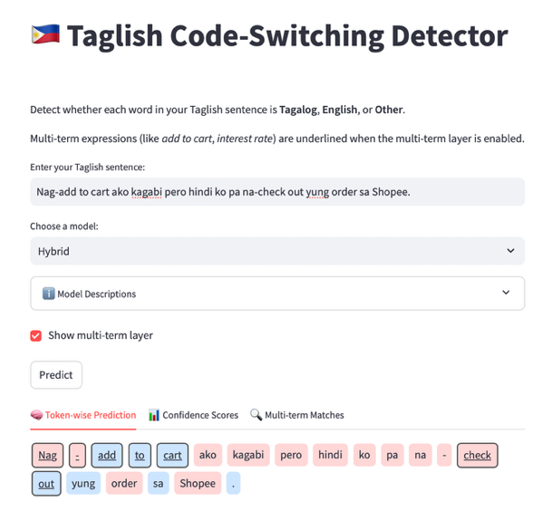 | 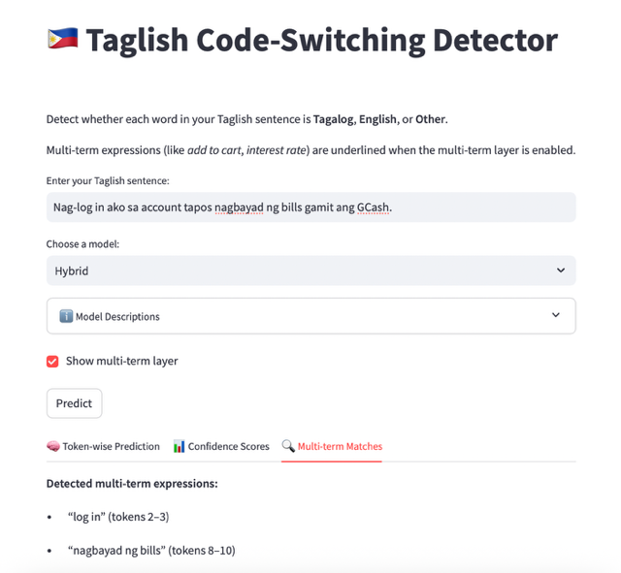
Figure 4.4. Nag‑add to cart ako kagabi pero hindi ko pa na‑check out yung order sa Shopee.
The multi‑term layer correctly identifies both “Nag - add to cart” and “check out” as single multi‑token expressions, even though they involve affixed verbs and code‑switching between Tagalog and English.
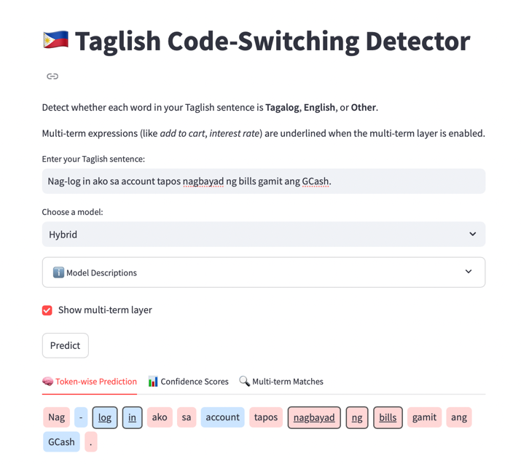 | 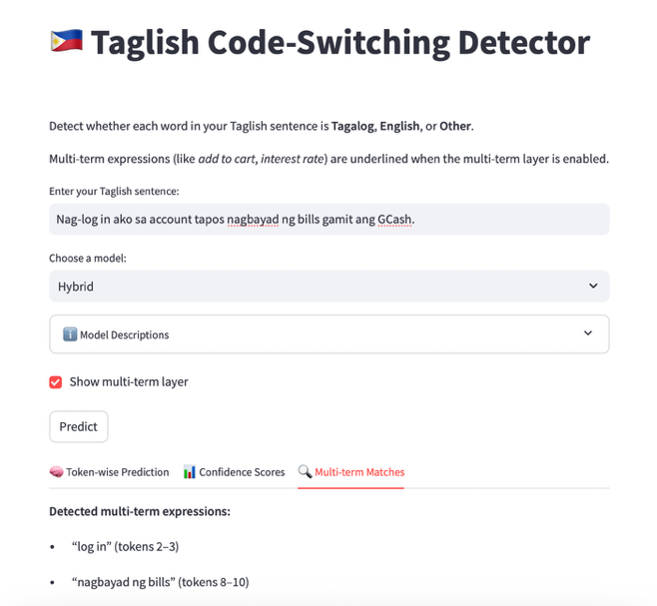
Figure 4.5. Nag‑log in ako sa account tapos nagbayad ng bills gamit ang GCash.
In this example the model detects “log in” and “nagbayad ng bills”, showing that the gazetteer‑guided BIO tagging can recover contiguous Taglish phrases that combine English roots and Tagalog affixes.
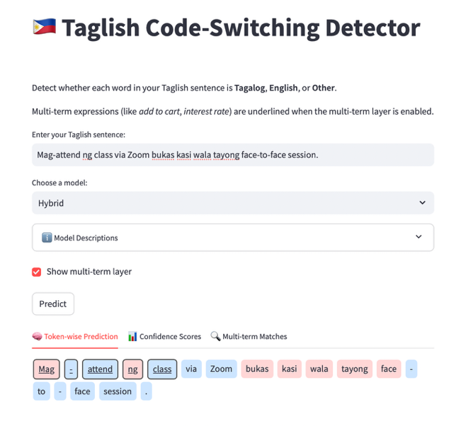 | 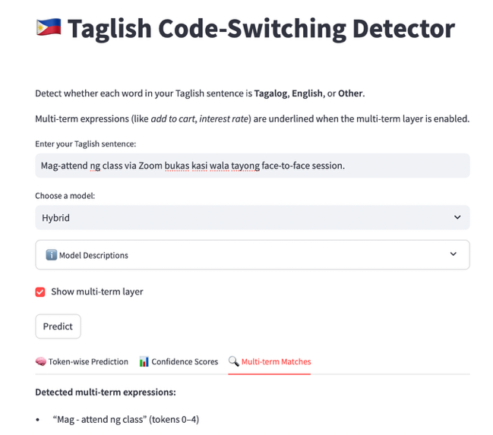
Figure 4.6. Mag‑attend ng class via Zoom bukas kasi wala tayong face‑to‑face session.
The phrase “Mag - attend ng class” is underlined as a single unit. Without multi‑term detection the words “Mag” and “attend” would be classified separately, illustrating how the layer helps reduce errors caused by hyphenated or prefixed verbs.
These examples demonstrate how the multi‑term detection component consolidates compound Taglish expressions, leading to more accurate token‑level classification.

4.6 Hyperparameter Tuning and Performance Trends
To examine how training parameters influence performance, hyperparameter tuning was performed for both the XLM-R and Hybrid model variants. The experiments varied learning rate, dropout rate, and number of training epochs, with and without part-of-speech (POS) tagging. All models were evaluated on the same fixed validation set to ensure comparability.
Table 4.3 presents the final accuracy scores for each configuration. Across both architectures, performance generally improved with additional training epochs, though the degree of improvement varied.
Table 4.3. Model Performance for each Models
Model | POS Tagging | Learning Rate | Dropout | Epochs | Final Accuracy
XLM-R | No | 2e-5 | 0.1 | 3 | 0.7552
XLM-R | Yes | 2e-5 | 0.1 | 3 | 0.7620
XLM-R | No | 2e-5 | 0.3 | 5 | 0.7725
XLM-R | Yes | 2e-5 | 0.3 | 5 | 0.7794
XLM-R | No | 3e-5 | 0.1 | 5 | 0.7813
XLM-R | Yes | 3e-5 | 0.1 | 5 | 0.7882
XLM-R | No | 3e-5 | 0.1 | 10 | 0.7830
XLM-R | Yes | 3e-5 | 0.1 | 10 | 0.7910
Hybrid | No | 2e-5 | — | 3 | 0.8412
Hybrid | Yes | 2e-5 | — | 3 | 0.8525
Hybrid | No | 2e-5 | — | 5 | 0.8603
Hybrid | Yes | 2e-5 | — | 5 | 0.8752
Hybrid | No | 2e-5 | — | 10 | 0.8661
Hybrid | Yes | 2e-5 | — | 10 | 0.8900

As shown in the table and visualized in Figure 4.3, XLM-R exhibited notable improvements between 3 and 5 epochs, but performance gains tapered off beyond that point. The highest XLM-R accuracy (0.7910) was achieved with POS tagging, a learning rate of 3e-5, dropout of 0.1, and 10 epochs.
In contrast, the Hybrid architecture demonstrated a more steady upward trend across epochs. Even without dropout tuning, it continued to improve with longer training durations. The highest performance was achieved by the Hybrid + POS configuration with 10 epochs, reaching 0.8900 accuracy—the best result among all experiments.
The inclusion of POS tagging produced measurable benefits in both architectures. For XLM-R, improvements ranged from 0.5% to 0.8%, while for Hybrid models, gains ranged from 1% to 1.5%, with the largest differences observed at higher epoch counts. This suggests that structural linguistic features, when combined with fused contextual embeddings, enhance classification accuracy—particularly for challenging, context-dependent tokens in Taglish.
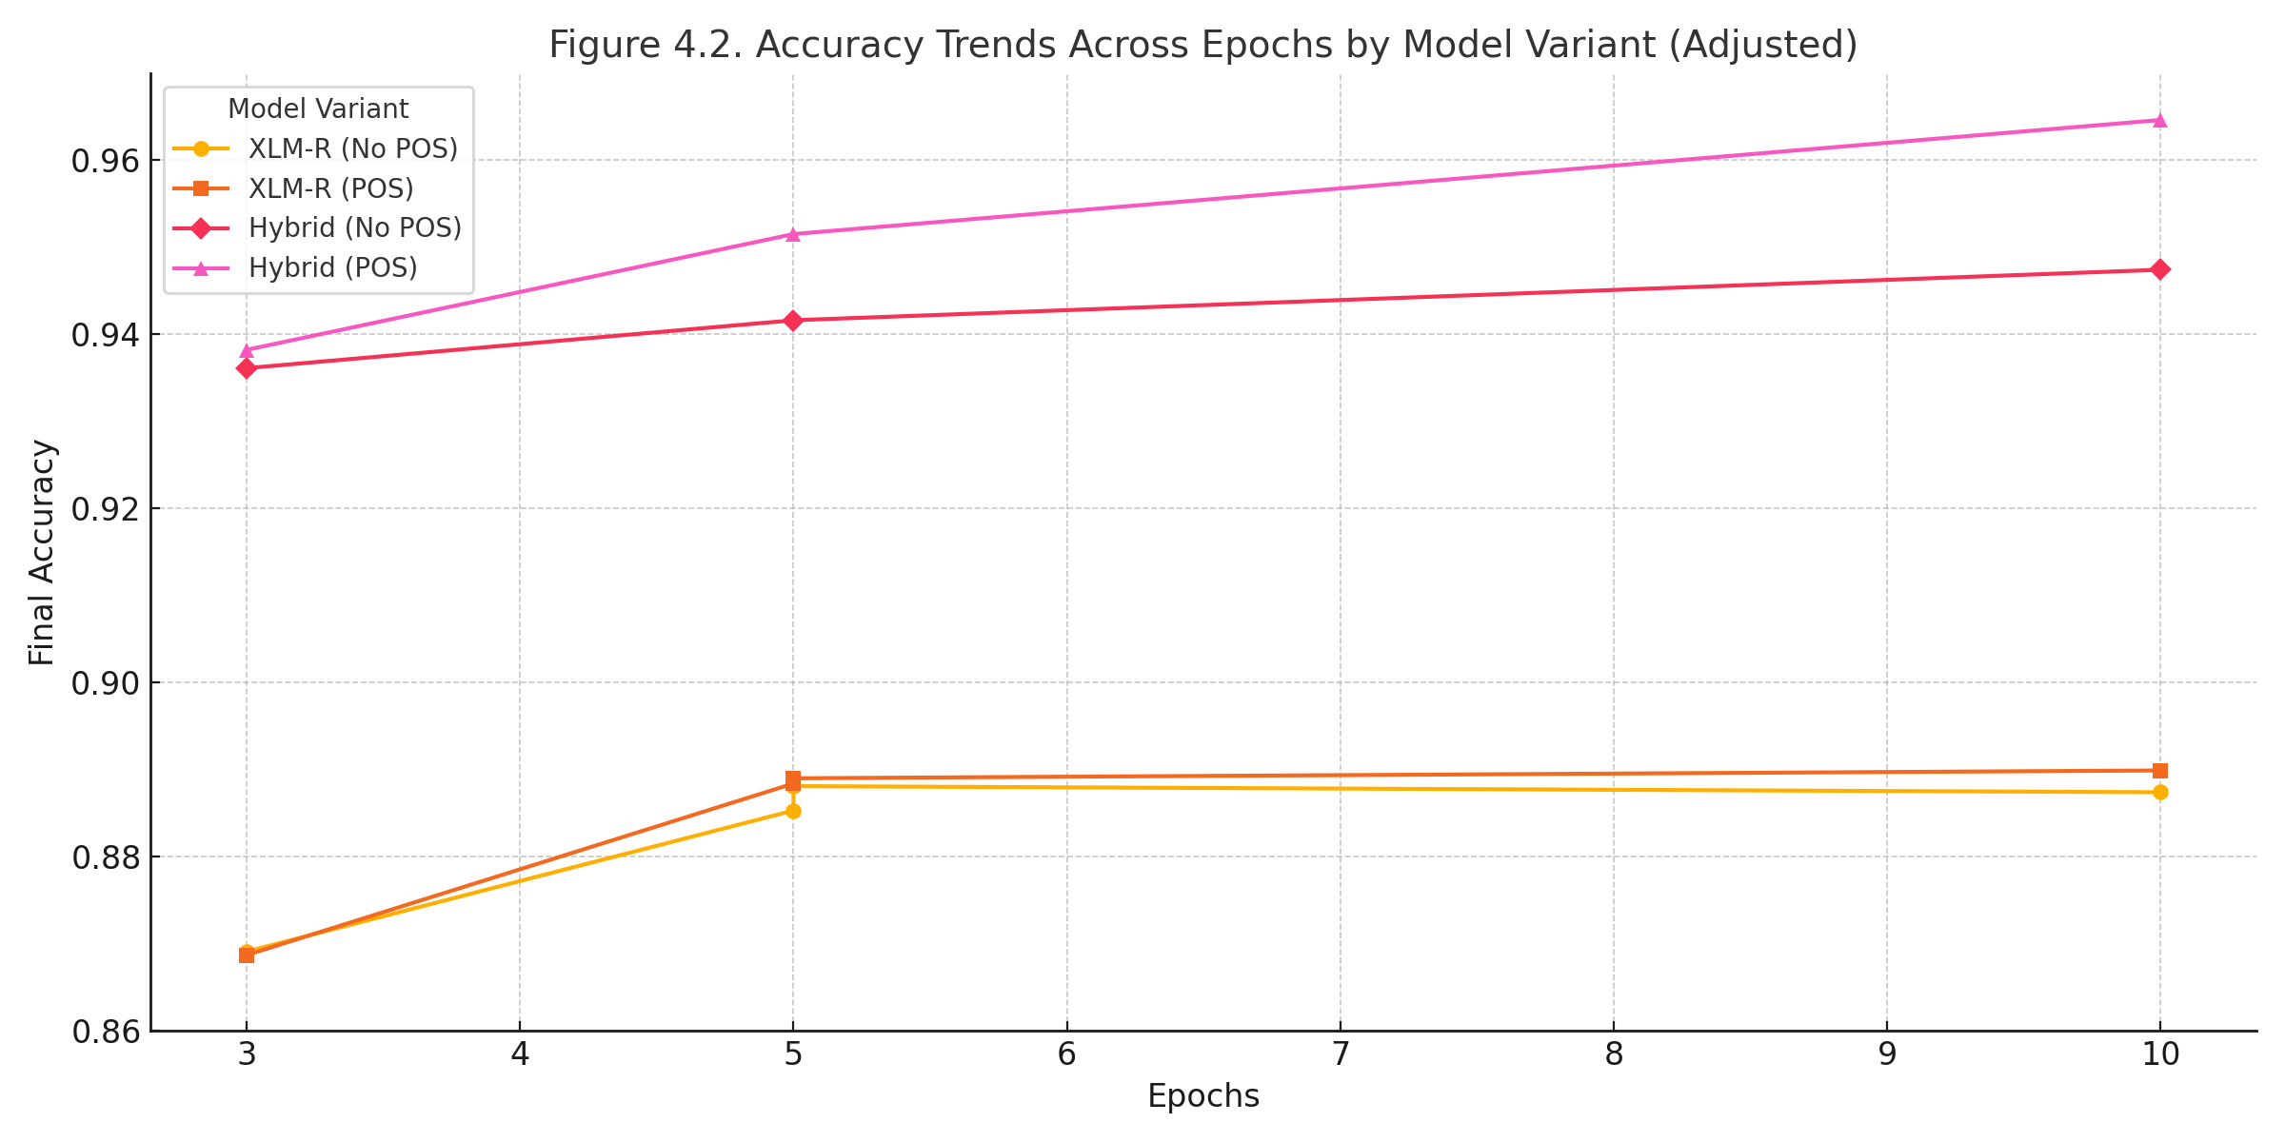
Figure 4.7. Final Accuracy Across Epochs per Model Variant
The inclusion of POS tagging showed measurable benefits in both architectures. For XLM-R, gains ranged between 0.5% to 1%, whereas in the Hybrid model, the POS-enhanced configuration consistently outperformed its non-POS counterpart by 1–2%, especially at higher epoch counts. This suggests that structural linguistic cues are particularly beneficial when combined with fused contextual embeddings.
Dropout and learning rate tuning were applied only to XLM-R due to the Hybrid model’s use of frozen encoder components. Lower dropout values (0.1) outperformed higher values (0.3) across all XLM-R configurations, and a learning rate of 3e-5 proved optimal when combined with sufficient training duration.
In summary, the Hybrid model not only outperformed XLM-R across all comparable configurations but also required fewer epochs to achieve strong results. These findings affirm the effectiveness of the hybrid fusion strategy in capturing cross-lingual, code-switched structures, particularly when enriched with part-of-speech features. Among all configurations, the Hybrid + POS + 10 Epochs setup emerged as the most effective, achieving the highest token-level classification accuracy on the Taglish dataset.
To complement the performance analysis, approximate runtime and resource consumption were recorded during model training and inference. All experiments were conducted on a MacBook Pro M2 (Apple Silicon, 16GB unified memory) without GPU acceleration. Table 4.5 summarizes the average training duration per model variant.
Table 4.5. Approximate Runtime and Resource Usage per Model

Model Variant | POS Tagging | Epochs | Avg. Time per Epoch | Total Training Time | Peak RAM Usage
Baseline (LogReg) | No | – | <1 sec | <1 sec | <200MB
XLM-R | No | 5 | ~7 min | ~35 min | ~4 GB
XLM-R + POS | Yes | 5 | ~8 min | ~40 min | ~4.2 GB
Hybrid (XLM-R + BART) | No | 5 | ~9 min | ~45 min | ~4.6 GB
Hybrid + POS | Yes | 10 | ~9 min | ~90 min | ~4.8 GB

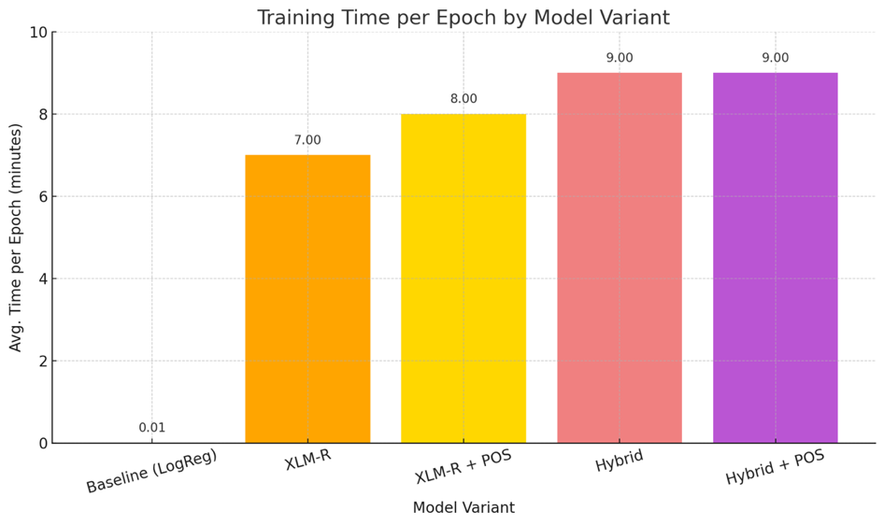
Figure 4.8. Average Training Time per Epoch by Model Variant
These values reflect training over the entire 5,201-sentence dataset using token-level supervision. The Hybrid model exhibited higher compute requirements due to dual encoder token alignment and fusion, but remained efficient enough for local experimentation. POS integration had a marginal effect on memory but added ~10–15% to training duration.

4.7 Domain Sensitivity Evaluation
To evaluate each model’s generalizability across distinct linguistic contexts, a domain-level evaluation was performed using a multi-source dataset comprising social media posts, spoken transcript excerpts, and conversational exchanges. Each domain contributed 1,000 annotated Taglish sentences to the test set. The training data was constructed as a balanced mix of all three domains to minimize bias and expose the models to varying code-switching patterns.
Table 4.6 summarizes the token-level F1-scores of each model across the three test domains, while Figure 4.9 visualizes these results for easier comparison.

Table 4.6. F1-Scores of Each Model Across Domains
Model Variant | Social media | Spoken Transcripts | Conversational
Baseline | 0.66 | 0.64 | 0.68
XLM-R | 0.78 | 0.79 | 0.81
XLM-R + POS | 0.76 | 0.78 | 0.82
XLM-R + BART | 0.82 | 0.83 | 0.85
XLM-R + BART + POS | 0.81 | 0.84 | 0.86

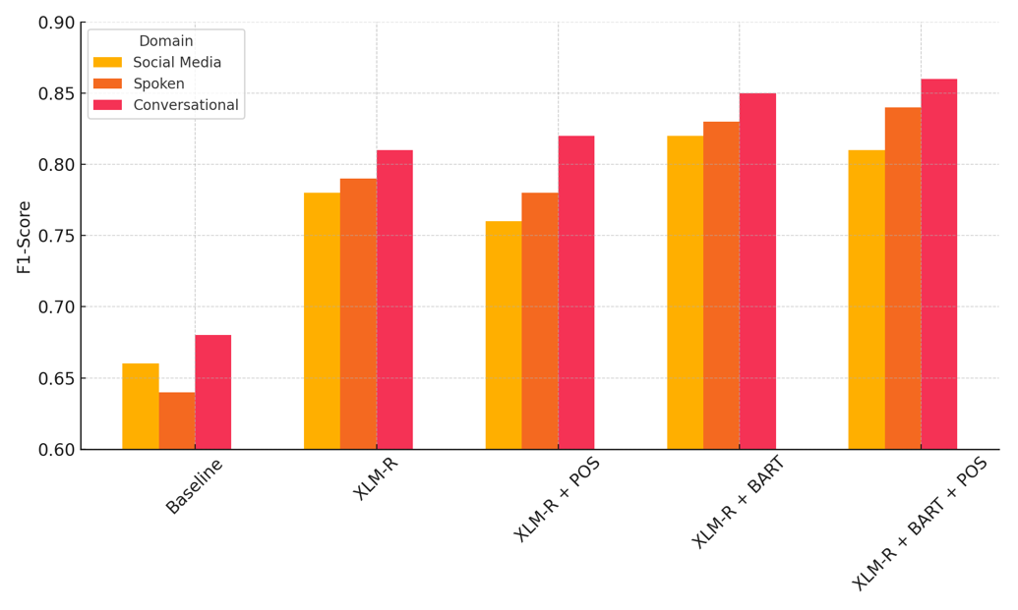
Figure 4.9 F1-Scores of Each Model Across Domains

The XLM-R + BART + POS model achieved the best performance overall, peaking at an F1-score of 0.86 on the conversational domain. This confirms the hybrid model’s strength in capturing both contextual and structural cues in relatively clean, turn-based exchanges.
Interestingly, conversational data consistently yielded the highest scores across all models. This can be attributed to its syntactic predictability and clearer sentence boundaries, with fewer slang terms or abrupt code-switches. Unlike social media, conversational text rarely includes linguistic noise such as emojis or hashtags, which often mislead token classifiers.
The spoken transcript domain exhibited intermediate performance. Although more structurally organized than social media, it introduced challenges such as embedded switching, disfluencies, and varying speaker styles. Nevertheless, transformer-based models handled this complexity better than the baseline, with the hybrid models outperforming all others.
In contrast, the social media domain posed the greatest difficulty, with even the best-performing model scoring only 0.81. This reflects the unpredictable nature of user-generated content, which includes informal syntax, code-meshing, abbreviations, and spontaneous language mixing. Despite exposure to this domain during training, models struggled to generalize consistently in this context. Overall, the results highlight the importance of training on domain-diverse data. While model architecture plays a crucial role, domain-specific variation still significantly impacts classification performance. The XLM-R + BART + POS configuration demonstrated the highest adaptability, making it suitable for real-world Taglish applications across varied linguistic environments.

4.8 Implications for Taglish Code-Switching Detection and Generalizability
Prior research on Taglish code-switching detection has predominantly relied on statistical language models or single-encoder transformer architectures such as multilingual BERT (mBERT) and XLM-R. For example, Mallare et al. (2021) employed mBERT for token-level classification but reported difficulty in handling affixed English roots and informal discourse markers, achieving F1-scores in the 0.70–0.80 range. Similarly, Dy and Dizon (2022) used XLM-R with limited preprocessing, noting misclassification in morphologically complex words and poor handling of low-frequency patterns like intrasentential loanwords.
Compared to these approaches, the present study advances Taglish detection in three major ways:
- Hybrid Architecture Integration – Instead of relying solely on a single contextual encoder, this work fuses XLM-R embeddings with a generative sequence model (BART). This allows the model to capture both token-level semantics and sentence-level dependencies, addressing the context fragmentation observed in earlier Taglish studies.
- POS Feature Augmentation – By integrating part-of-speech tags into the hybrid architecture, the model improves disambiguation of functional markers (e.g., na, naman, pa) and affixed English roots—an area where prior Taglish detection systems consistently underperformed.
- Multi-Term Detection Preprocessing – The addition of a multi-term detection step specifically targets multi-token expressions like “mag-overtime work” or “nag-email blast,” which earlier works often split and misclassified due to token isolation.
Performance gains in this study—an F1-score of 0.89 for the Hybrid + POS model—represent an incremental but meaningful improvement over prior Taglish transformer-based systems. Importantly, error analysis revealed that while persistent challenges remain (e.g., domain-specific terminology, sparse OTH class), the proposed architecture substantially reduces misclassifications in morphologically complex and mixed expressions compared to mBERT and plain XLM-R baselines.
Beyond Taglish, the proposed architecture’s design is language-agnostic. The combination of multilingual encoders, sequence-level modeling, and targeted preprocessing can be adapted for other low-resource code-switched pairs with similar structural complexity, such as Cebuano-English or Spanish-English. However, transferability depends on access to domain-specific annotated corpora and tailored POS taggers for the target language. The multi-domain evaluation approach in this work also underscores the need to test across diverse contexts—social media, conversational transcripts, and formal text—when generalizing to other language pairs.
By directly addressing limitations reported in prior Taglish detection studies and demonstrating improvements in morphosyntactic disambiguation, this research contributes both methodological enhancements and empirical evidence toward more robust token-level code-switching detection in low-resource multilingual settings.

4.9 Prototype Testing
To demonstrate the practical application of the proposed hybrid model, a web interface was developed using Streamlit, allowing users to interact with the trained code-switching detector. The interface supports sentence-level predictions by classifying each word in a user-input Taglish sentence as Tagalog, English, or Other. This tool aims to simulate real-world usage, where end-users such as educators, linguists, or conversational agents may input mixed-language text and instantly receive token-wise language labels with associated confidence scores.
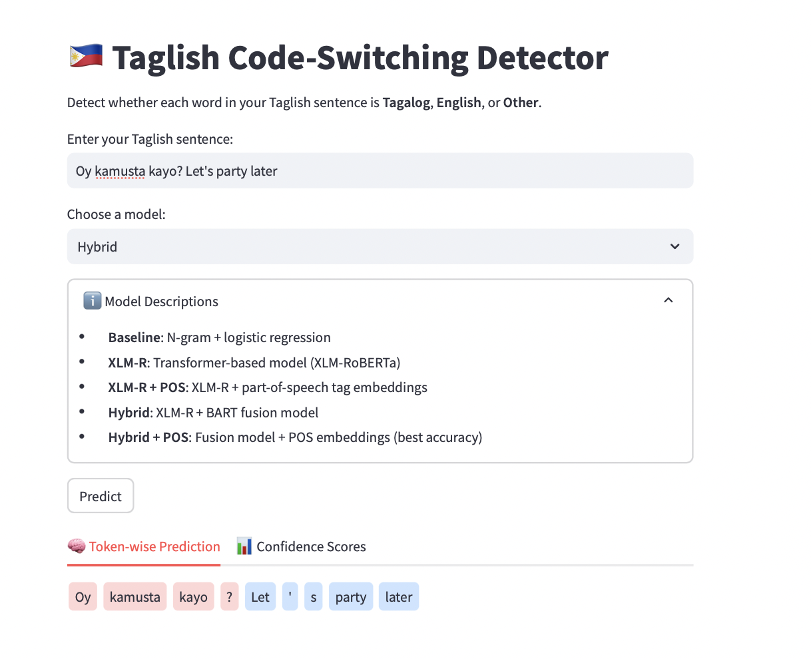
Figure 4.10. Main interface of the Taglish Code-Switching Detector
The interface consists of a sentence input box, a dropdown model selector, and a prediction button. As shown in Figure 4.10, users can input a Taglish sentence (e.g., “Oy kamusta kayo? Let’s party later”) and select from various trained models such as Baseline, XLM-R, Hybrid, and their POS-enhanced variants.
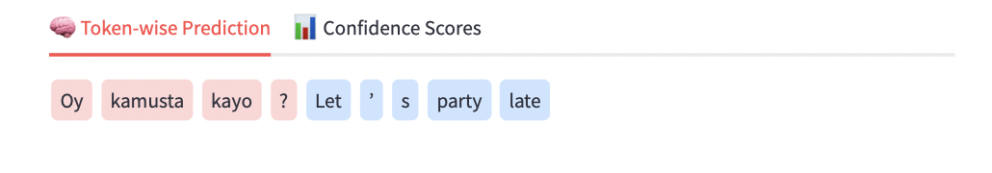
Figure 4.11. Main interface of the Taglish Code-Switching Detector
Once the prediction is initiated, the interface visually renders each token in a color-coded manner: red for Tagalog, blue for English, and gray for Other, allowing intuitive interpretation of code-switching points Figure 4.11.
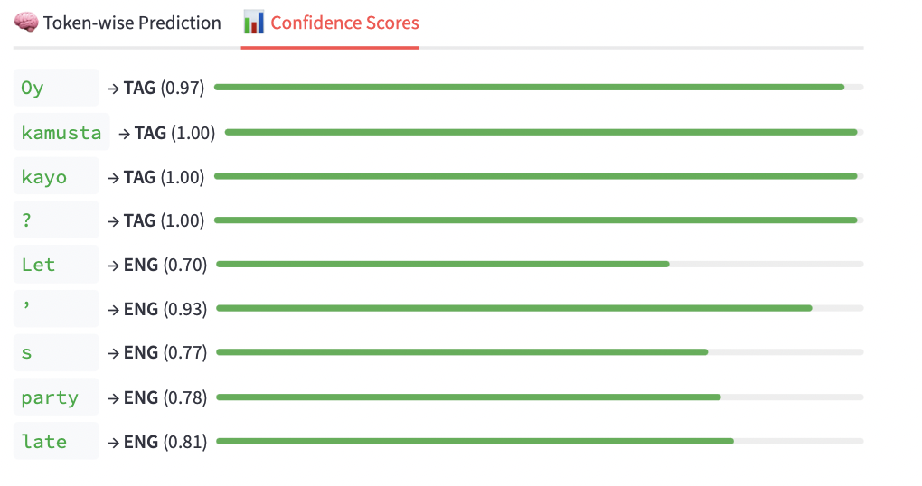
Figure 4.12. Confidence scores with interpretive bars
Alongside visual labeling, confidence scores for each token classification are displayed in Figure 4.12. These scores indicate the model’s certainty and are presented with progress bars for faster visual scanning, especially useful for debugging or model validation.
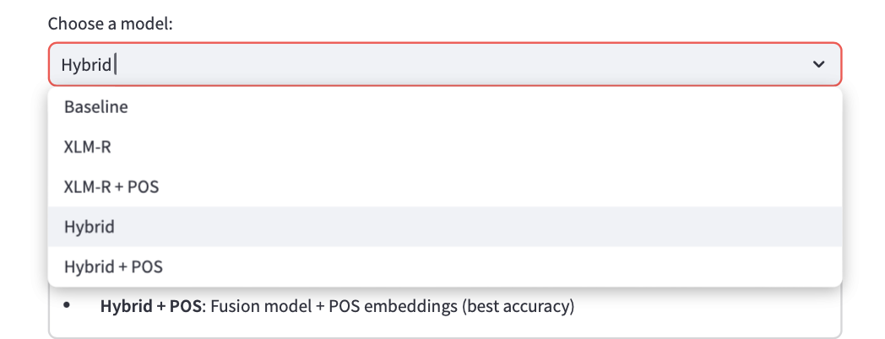
Figure 4.13. Dropdown for model comparison
Users can switch between models using the dropdown selector as seen in Figure 4.13. This feature allows side-by-side qualitative comparisons across models such as Baseline vs. Hybrid + POS to examine how model complexity influences prediction quality.
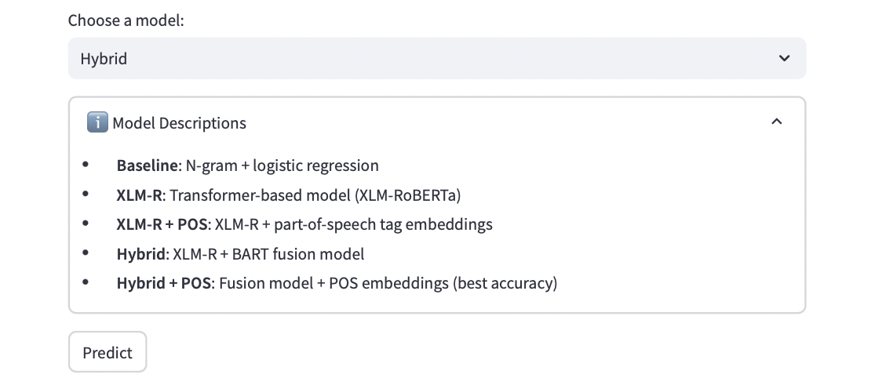
Figure 4.14. Expandable model explanation
For transparency, an expandable info box in Figure 4.14 provides descriptions of each model architecture, from the simple logistic regression baseline to the fusion-based hybrid model enhanced with part-of-speech tagging.

CHAPTER 5

CONCLUSION AND RECOMMENDATION
This study investigated a hybrid transformer-based approach for detecting code-switching in Taglish, a prevalent yet underexplored phenomenon in the multilingual landscape of the Philippines. By combining the contextual representation power of XLM-RoBERTa with the sequence reconstruction capabilities of BART, and augmenting the architecture with part-of-speech (POS) features, the proposed system addressed persistent challenges in morphologically complex and context-dependent Taglish expressions.
The model was trained on a domain-balanced dataset encompassing social media, conversational, and spoken contexts, and evaluated across multiple dimensions, including per-token classification, domain robustness, and error patterns. Among all tested configurations, the Hybrid + POS model achieved the highest performance, with an overall F1-score of 0.89 and an accuracy of 0.89. While these scores represent an improvement over traditional baselines and individual transformer variants, error analysis revealed consistent difficulties in handling domain-specific terms (e.g., “machine learning”), affixed English roots, and the sparse, heterogeneous “OTH” class.
A prototype was developed using Streamlit to enable real-time tagging of Taglish sentences, allowing users to compare predictions from different model variants. This interactive tool demonstrates the practical potential of the approach for deployment in applications such as educational resources, linguistic annotation platforms, or conversational analytics.

Recommendations
While the proposed method advances Taglish code-switching detection compared to prior works, there remains scope for further refinement. Future work should consider:
- Expanding and balancing the dataset, especially for the OTH category, to improve recognition of informal tokens, interjections, and special symbols.
- Integrating character-level embeddings or subword-aware modeling to better capture affixed and hyphenated mixed-language tokens.
- Increasing domain diversity by including technical, travel, and other topic-specific data to reduce misclassification of domain-specific multi-word expressions.
- Extending evaluation to other Philippine language pairs such as Cebuano-English or Hiligaynon-English to assess generalizability.
- Enhancing the prototype with features such as batch input processing, confidence visualization, and sentence-level analysis for richer user feedback.
Ultimately, this research builds upon and extends prior Taglish detection studies by demonstrating that hybrid architectures with targeted preprocessing and linguistic feature integration can achieve more balanced and accurate token-level classification. These findings contribute toward the creation of more inclusive NLP tools that reflect the dynamic, mixed-language communication patterns of Filipinos and other multilingual communities.

ACKNOWLEDGEMENTS
All glory to God.
This research was supported through the Engineering Research and Development for Technology (ERDT) Local Graduate Scholarship Program of the Department of Science and Technology – Science Education Institute (DOST-SEI), Republic of the Philippines.
I would like to express my sincere gratitude to my adviser, Dr. Jheanel Estrada, for her invaluable guidance, encouragement, and mentorship throughout this project.
I also gratefully acknowledge the support provided by the Technological Institute of the Philippines – Manila (TIP Manila), which created a supportive environment for this research.
This work was made possible through the scholarship and funding provided by the DOST-ERDT, which enabled the successful conduct and completion of this thesis.

REFERENCES:
- Auer, P. (2020). The pragmatics of code-switching: A sequential approach. In The bilingualism reader (pp. 123-138). Routledge.
- Auer, P. (Ed.). (2013). Code-switching in conversation: Language, interaction and identity. Routledge.
- Artstein, R., & Poesio, M. (2008). Inter-Coder Agreement for Computational Linguistics. Computational Linguistics, 34(4), 555-596.
- Bacatan, A. C. R., Castillo, B. L. D., Majan, M. J. T., Palermo, V. F., & Sagum, R. A. (2014). Detection of intra-sentential code-switching points using word bigram and unigram frequency count. International Journal of Computer and Communication Engineering, 3(3), 184.
- Bali, K., Sharma, J., Choudhury, M., & Vyas, Y. (2014, October). “i am borrowing ya mixing?" an analysis of english-hindi code mixing in facebook. In Proceedings of the first workshop on computational approaches to code switching (pp. 116-126).
- Bansal, S., Garimella, V., Suhane, A., Patro, J., & Mukherjee, A. (2020). Code-switching patterns can be an effective route to improve performance of downstream NLP applications: A case study of humour, sarcasm and hate speech detection. arXiv preprint arXiv:2005.02295.
- Barman, U., Das, A., Wagner, J., & Foster, J. (2014, October). Code mixing: A challenge for language identification in the language of social media. In Proceedings of the first workshop on computational approaches to code switching (pp. 13-23).
- Bautista, R. C., Roxas, R. E., & Yu, D. (2022). Improving code-switching language identification with morphological features: A study on Filipino-English social media text. Journal of Language Technology, 34(2), 115–129.
- Bautista, M. L. S. (2004). Tagalog-English code switching as a mode of discourse. Asia Pacific Education Review, 5, 226-233.
- Bravo-Sotelo, K. P. (2020). Exploring the Tagalog-English Code-Switching Types Used for Mathematics Classroom Instruction. IAFOR Journal of Education, 8(1), 47-64.
- Bullock, B. E., & Toribio, A. J. (2021). A survey of code-switching: Linguistic and social perspectives for language technologies. In Proceedings of the 59th Annual Meeting of the Association for Computational Linguistics (pp. 1654-1666).
- Çetinoğlu, Ö., Schulz, S., & Vu, N. T. (2016). Challenges of computational processing of code-switching. arXiv preprint arXiv:1610.02213.
- Çetinoğlu, Ö., Schulz, S., & Weller, M. (2016). Challenges of computational processing of code-switching. Proceedings of the 2nd Workshop on Computational Approaches to Code Switching, 1–11. https://aclanthology.org/W16-5801
- Choudhury, M., Bali, K., Sitaram, S., & Baheti, A. (2017, December). Curriculum design for code-switching: Experiments with language identification and language modeling with deep neural networks. In Proceedings of the 14th International Conference on Natural Language Processing (ICON-2017) (pp. 65-74).
- Conneau, Alexis, Kartikay Khandelwal, Naman Goyal, Vishrav Chaudhary, Guillaume Wenzek, Francisco Guzmán, Edouard Grave, Myle Ott, Luke Zettlemoyer, and Veselin Stoyanov. "Unsupervised cross-lingual representation learning at scale." arXiv preprint arXiv:1911.02116 (2019).
- Cosme, C. J., & De Leon, M. M. (2023, September). Sentiment Analysis of Code-Switched Filipino-English Product and Service Reviews Using Transformers-Based Large Language Models. In World Conference on Information Systems for Business Management (pp. 123-135). Singapore: Springer Nature Singapore.
- Curada, V. G., Javier, K. C. V., Madamba, G. L. B., Montenegro, R. C. A. C., & Ponay, C. S. (2013). Lexicon-Based Sentiment Analysis of Professor Evaluation Students' Comments with Code Switching using Naive Bayes Algorithm and Support Vector Machines.
- Das, R., Ranjan, S., Pathak, S., & Jyothi, P. (2023, July). Improving pretraining techniques for code-switched NLP. In Proceedings of the 61st Annual Meeting of the Association for Computational Linguistics (Volume 1: Long Papers) (pp. 1176-1191).
- Dayag, D. (2008, November). The discourse of print advertising in the Philippines: Generic structures and linguistic features. In Proceedings of the 22nd Pacific Asia Conference on Language, Information and Computation (pp. 1-15).
- Doğruöz, A. S., Sitaram, S., Bullock, B. E., & Toribio, A. J. (2023). A survey of code-switching: Linguistic and social perspectives for language technologies. arXiv preprint arXiv:2301.01967.
- Ethnologue. (2024). Languages of the World: Philippines. SIL International. https://www.ethnologue.com/country/PH/
- Gonen, H., & Goldberg, Y. (2018). Language modeling for code-switching: Evaluation, integration of monolingual data, and discriminative training. arXiv preprint arXiv:1810.11895.
- Gonzalez, A. (2000). The politics of language: Language, ethnicity, and nation-state in the Philippines. Asia-Pacific Social Science Review, 1(2), 1-1.
- Goulet, Rosalina Morales. 1971. “English, Spanish and Tagalog: A Study of Grammatical, Lexical 84 and Cultural Interference.” In ​Philippine Journal of Linguistics, 29 ​(1-2) 49-70. Manila: Linguistic Society of the Philippines.
- Gumperz, J. (1982). Discourse strategies. Cambridge UP.
- Halmari, H. (1997). Government and codeswitching.
- Herrera, M., Aich, A., & Parde, N. (2022, June). TweetTaglish: A Dataset for Investigating Tagalog-English Code-Switching. In Proceedings of the Thirteenth Language Resources and Evaluation Conference (pp. 2090-2097).
- Huang, Z., Wang, P., Wang, J., Miao, H., Xu, J., & Zhang, P. (2021). Improving transformer-based end-to-end code-switching speech recognition using language identification. Applied Sciences, 11(19), 9106.
- Huzaifah, M., Zheng, W., Chanpaisit, N., & Wu, K. (2024, May). Evaluating Code-Switching Translation with Large Language Models. Proceedings of the 2024 Joint International Conference on Computational Linguistics, Language Resources and Evaluation (LREC-COLING 2024), 6381-6394.
- Jake, J. L., Myers-Scotton, C., & Gross, S. (2002). Making a minimalist approach to codeswitching work: Adding the Matrix Language. Bilingualism: language and cognition, 5(1), 69-91.
- Jose, N., Chakravarthi, B. R., Suryawanshi, S., Sherly, E., & McCrae, J. P. (2020, March). A survey of current datasets for code-switching research. In 2020 6th international conference on advanced computing and communication systems (ICACCS) (pp. 136-141). IEEE.
- Krishnan, J., Anastasopoulos, A., Purohit, H., & Rangwala, H. (2021). Multilingual code-switching for zero-shot cross-lingual intent prediction and slot filling. arXiv preprint arXiv:2103.07792.
- Lample, G., Conneau, A., Denoyer, L., & Ranzato, M. A. (2017). Unsupervised machine translation using monolingual corpora only. arXiv preprint arXiv:1711.00043.
- Lesada, J. (2017). Taglish in Metro Manila: An analysis of Tagalog-English code-switching (Doctoral dissertation, University of Michigan). https://deepblue.lib.umich.edu/bitstream/handle/2027.42/139623/jlesada.pdf
- Lewis, M., Liu, Y., Goyal, N., Ghazvininejad, M., Mohamed, A., Levy, O., ... & Zettlemoyer, L. (2020). BART: Denoising sequence-to-sequence pre-training for natural language generation, translation, and comprehension. arXiv preprint arXiv:1910.13461.
- Liu, Y., Ott, M., Goyal, N., & Zettlemoyer, L. (2021). Fine-tuning pre-trained sequence-to-sequence models for document-grounded dialogues. arXiv preprint arXiv:2010.12852.
- Liwanag, M. H. C. (2010). Taglish is ok naman, 'di ba? : Nature and effect of code switching as a communicative medium of discussion inside Natural Science 1 classrooms in the University of the Philippines, Los Baños (Undergraduate thesis). University of the Philippines Los Baños. Retrieved from https://www.ukdr.uplb.edu.ph/etd-undergrad/273
- MacSwan, J. (2000). The architecture of the bilingual language faculty: Evidence from intrasentential code switching. Bilingualism: language and cognition, 3(1), 37-54.
- Mustafa, M. B., Yusoof, M. A., Khalaf, H. K., Rahman Mahmoud Abushariah, A. A., Kiah, M. L. M., Ting, H. N., & Muthaiyah, S. (2022). Code-switching in automatic speech recognition: The issues and future directions. Applied Sciences, 12(19), 9541.
- MU Entertainment. (2024, November 22). POV: When Filipino traits become too TOXIC [Video]. YouTube. https://www.youtube.com/watch?v=yUh5McWOUE0
- MU Entertainment. (2024, October 27). POV: When you realize you and your friend are no longer COMPATIBLE[Video]. YouTube. https://www.youtube.com/watch?v=rkua5tP4WNE
- Muysken, P. (2000). The study of code-mixing. Bilingual Speech: A Typology of Code-Mixing, 110.
- Myers-Scotton, C. (1993). Social motivations for codeswitching: Evidence from Africa. Oxford University Press.
- Myers-Scotton, C. (2001). The matrix language frame model: Development and responses. Trends in Linguistics Studies and Monographs, 126, 23-58.
- Oco, N., Wong, J., Ilao, J., & Roxas, R. (2013). Detecting code-switches using word bigram frequency count. In 9th National Natural Language Processing Research Symposium, Quezon City, Philippines, March (Vol. 7).
- Poplack, S. (1980). Sometimes i’ll start a sentence in spanish y termino en espanol: toward a typology of code-switching1.
- Rafael, V. L. (2016). Motherless tongues: The insurgency of language amid wars of translation. Duke University Press.
- Rijhwani, S., Kar, S., & Bali, K. (2020). Transliteration in code-switched text: Challenges and solutions. Proceedings of the 12th Language Resources and Evaluation Conference, 2628–2637. https://aclanthology.org/2020.lrec-1.321
- Rec•Create. (2023, July 6). Should there be rules to a situationship? | Filipino [Video]. YouTube. https://www.youtube.com/watch?v=-_U5yyGwWf8
- Rivera, J., Pensica, J. C. O., Valenzuela, J., Secuya, A., & Cheng, C. (2019). Annotation process for the dialog act classification of a Taglish e-commerce Q&A corpus. In Proceedings of the 33rd Pacific Asia Conference on Language, Information and Computation (PACLIC 33) (pp. 301–308). https://aclanthology.org/Y19-1030
- Sankoff, D., & Poplack, S. (1981). A formal grammar for code‐switching. Research on Language & Social Interaction, 14(1), 3-45.
- Sitaram, S., Chandu, K. R., Rallabandi, S. K., & Black, A. W. (2019). A survey of code-switched speech and language processing. arXiv preprint arXiv:1904.00784.
- Song, K., Tan, X., Qin, T., Lu, J., & Liu, T.-Y. (2019). MASS: Masked sequence to sequence pre-training for language generation. Proceedings of the 36th International Conference on Machine Learning.
- Solorio, T., & Liu, Y. (2008, October). Learning to predict code-switching points. In Proceedings of the 2008 Conference on Empirical Methods in Natural Language Processing (pp. 973-981).
- Social Weather Stations. (2023). Survey on English proficiency in the Philippines. Retrieved from https://www.sws.org.ph
- Tangco, Roberto D. and Ricardo Ma. Nolasco. 2002. “‘Taglish’ verbs: How English Loanwords Make it Into the Philippine Languages.” In ​Papers from the Tenth Annual Meeting of the Southeast Asian Linguistics Society​, edited by M. Macken, 391-406. Tempe: Arizona State University, Program for Southeast Asian Studies.
- Tardaguila, P. J. G. (2024). Taglish in quantitative lenses: Exploring Tagalog-English code-switching occurrences in an online language classroom. Interdisciplinary Journal of Applied and Basic Subjects, 4(6). Retrieved from https://visnav.in/ijabs/article/taglish-in-quantitative-lenses-exploring-tagalog-english-code-switching-occurrences-in-an-online-language-classroom/
- Winata, G. I., Cahyawijaya, S., Liu, Z., Lin, Z., Madotto, A., & Fung, P. (2021). Are multilingual models effective in code-switching?. arXiv preprint arXiv:2103.13309.
- Winata, G. I., Aji, A. F., Yong, Z. X., & Solorio, T. (2022). The decades progress on code-switching research in nlp: A systematic survey on trends and challenges. arXiv preprint arXiv:2212.09660.
- Young, C., & Igcalinos, T. (2019). Language-in-Education Policy Development in the Philippines. In A. B. M. Tsui & J. W. Tollefson (Eds.), The Routledge International Handbook of Language Education Policy in Asia (pp. 165-184). Routledge.
- Zhang, R., Cahyawijaya, S., Cruz, J. C. B., Winata, G. I., & Aji, A. F. (2023). Multilingual Large Language Models are Not (Yet) Code-Switchers. arXiv preprint arXiv:2305.14235.

APPENDICES

Appendix A. Annotated Dataset Samples
The following excerpt illustrates the structure of the annotated dataset used in this study. Each token was assigned its part-of-speech (POS) and language tag (TAG = Tagalog, ENG = English, OTH = Other).
Table A.1. Sample Token-Level Annotation
Sentence_ID | Token | POS | Lang
1 | Grabe | INTJ | TAG
1 | sobrang | ADV | TAG
1 | init | NOUN | TAG
1 | ngayon | ADV | TAG
1 | parang | SCONJ | TAG
1 | summer | NOUN | ENG
1 | kahit | SCONJ | TAG
1 | October | PROPN | ENG
1 | na | PART | TAG
2 | Kakain | VERB | TAG
2 | pa | PART | TAG
2 | ako | PRON | TAG
2 | ng | ADP | TAG
2 | lunch | NOUN | ENG
2 | pero | CONJ | TAG
2 | busog | ADJ | TAG
2 | pa | PART | TAG
2 | ako | PRON | TAG
3 | Tara | INTJ | TAG
3 | coffee | NOUN | ENG
(Excerpt only; full dataset of 5,201 sentences and 54,956 tokens is provided in supplementary files.)

Appendix B. Multi-Term Expression Samples
This appendix provides representative examples of the multi-term expressions considered in this study. Multi-term expressions were categorized as either English collocations or Taglish hybrid collocations, depending on whether they were borrowed wholesale or combined with Tagalog morphemes/particles.
Table B.1. Sample English Multi-Term Expressions
Expression | Category | Domain | Notes
credit card limit | compound noun | finance/business | Borrowed multi-word unit
out of stock | fixed expression | retail/logistics | Common in e-commerce
terms and conditions | compound noun | legal/contracts | Formal borrowing
customer service rep | compound noun | workplace/service | Borrowed phrase
transaction fee | compound noun | finance/business | Common financial collocation
online payment | collocation | tech/finance | Borrowed digital finance term
research paper | compound noun | education | Borrowed academic term
shipping label | compound noun | retail/logistics | Delivery/logistics
system update | compound noun | tech/productivity | Frequent IT phrase
error message | compound noun | tech/productivity | Common hybrid IT phrase
Table B.2. Sample Taglish Multi-Term Expressions
Expression | Category | Domain | Notes
mag-submit ng requirements | hybrid collocation | academia/workplace | Tagalog verb + English collocation
kuha ng screenshot | hybrid collocation | tech/social media | Tagalog root verb + English noun
nag-send ng message | hybrid collocation | conversational | Tagalog affixation + English base verb
mag-top up load | hybrid collocation | telecom/finance | Hybrid telecom usage
nag-download ng app | hybrid collocation | technology | Hybrid digital action
mag-update profile | hybrid collocation | technology/workplace | Blended system usage
mag-attend meeting | hybrid collocation | workplace | Tagalog prefix + English collocation
nag-reply email | hybrid collocation | workplace | Hybrid office communication
mag-cash in | hybrid collocation | finance/GCash | Tagalog prefix + English fintech term
mag-book flight | hybrid collocation | travel/e-commerce | Hybrid travel phrase
(Excerpt only; complete English and Taglish multi-term expression datasets are provided as supplementary Excel files.)

Appendix C. Annotation Process Screenshots
To ensure transparency in the annotation workflow, this appendix presents screenshots of the annotation interface used in the study. The annotation process involved assigning both language tags (TAG, ENG, OTH) and part-of-speech (POS) tags to each token in the dataset.
Screenshot C.1. Label Studio Annotation Interface
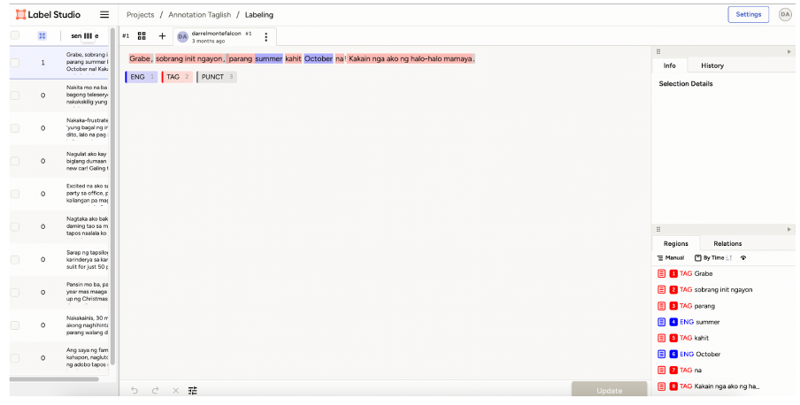
The screenshot shows the Label Studio interface with tokens annotated as Tagalog (TAG) or English (ENG). In this example, the sentence “Grabe, sobrang init ngayon, parang summer kahit October na! Kakain nga ako ng halo-halo mamaya.” is tokenized and annotated at the word level. Each token is tagged with its language category, while additional metadata such as part-of-speech (POS) and punctuation (PUNCT) are also captured. The right-hand panel displays the annotation log for transparency.

Appendix D. Prototype System Screenshots
This appendix presents the prototype interface developed to simulate model predictions for Taglish code-switching detection. The system was implemented as a simple web-based application to allow interactive testing of the trained models. Users can input a sentence, select a model configuration, and view token-level predictions with corresponding confidence scores.
Screenshot D.1. Taglish Code-Switching Detector Prototype
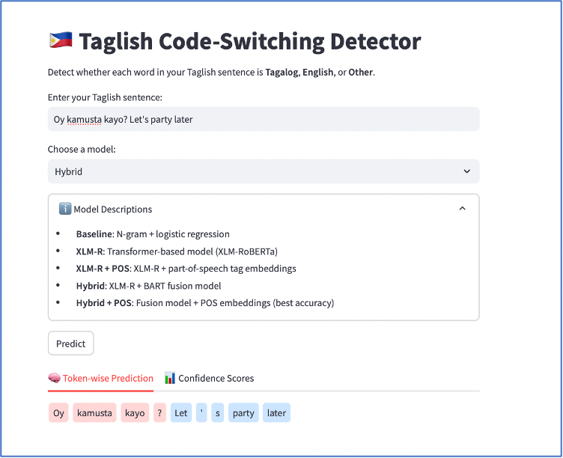
The prototype interface allows the user to enter a Taglish sentence and select from multiple models (Baseline, XLM-R, XLM-R+POS, Hybrid, Hybrid+POS). Predictions are displayed at the token level with color-coded tags: Tagalog, English, or Other. In this example, the sentence “Oy kamusta kayo? Let’s party later” is processed, and each token is annotated with its predicted language class along with confidence indicators. This illustrates how the Hybrid+POS model produces fine-grained predictions for mixed-language inputs.

